

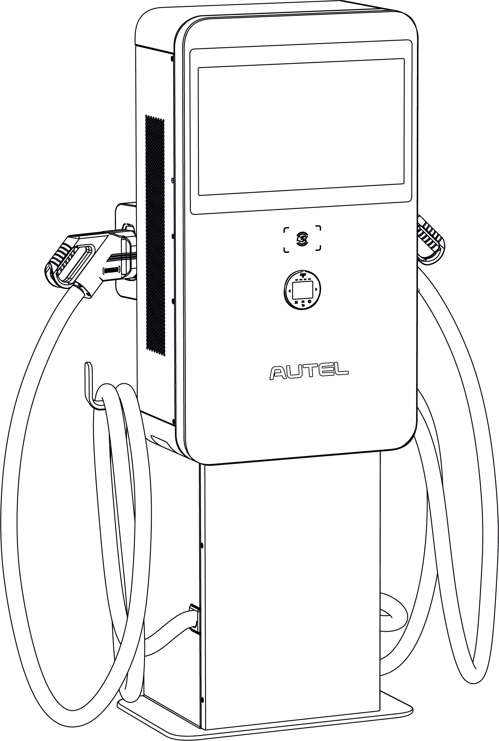

**Installation and Operation Manual**

MaxiCharger DC Wall Mount (EU)

Trademarks

Autel® and MaxiCharger® are trademarks of Autel Intelligent Technology Corp., Ltd., registered in China, the United States and other countries. All other marks are trademarks or registered trademarks of their respective holders.

Copyright Information

No part of this manual may be reproduced, stored in a retrieval system or transmitted, in any form or by any means, electronic, mechanical, photocopying, recording, or otherwise without the prior written permission of Autel.

Disclaimer of Warranties and Limitation of Liabilities

All information, specifications and illustrations in this manual are based on the latest information available at the time of printing.

Autel reserves the right to make changes at any time without notice. While information of this manual has been carefully checked for accuracy, no guarantee is given for the completeness and correctness of the contents, including but not limited to the product specifications, functions, and illustrations.

Autel will not be liable for any direct, special, incidental, indirect damages or any economic consequential damages (including the loss of profits).

**IMPORTANT**

Before operating or maintaining this unit, please read this manual carefully, paying extra attention to the safety warnings and precautions.

For Services and Support:

Web: www.autelenergy.com

Tel: +49 (0) 89 540299608 (Europe)

0086-755-2267-2493 (China)

Email: evsupport.eu@autel.com

For technical assistance in all other markets, please contact your local selling agent.

**CONTENTS**

1 Using This Manual 1

1.1 Conventions 1

1.1.1 Bold Text 1

1.1.2 Signal Words 1

1.1.3 Hyperlinks 1

1.1.4 Illustrations 1

1.1.5 Revision History 2

2 Safety 3

2.1 Safety Warnings 3

2.2 Disposal Instructions 3

3 General Introduction 4

3.1 Product Overview (Outside) 5

3.2 Product Overview (Inside) 6

3.3 Technical Specifications 7

4 Preparation 11

4.1 Before You Begin 11

4.2 Installation Tools 12

5 Installation 13

5.1 Unpacking 15

5.2 Moving the MaxiCharger 16

5.3 Installing MaxiCharger and Pedestal 18

5.4 Installing MaxiCharger Mounted on Pedestal 30

5.5 Installing MaxiCharger and Trolley 39

5.6 Power Supply Wiring 44

5.6.1 Opening the Door 45

5.6.2 Connecting the AC Input Cable 46

5.7 Connecting to the Internet 48

5.7.1 Via the Ethernet Cable 48

5.7.2 Via the Cellular Network 49

5.8 Installing the Upstream Protective Device 50

5.9 Connecting the Industrial Plug to the Socket 50

5.10 Preparing for Commissioning 51

5.11 Powering on the MaxiCharger 52

6 Operation 53

6.1 Charging Procedure 53

6.1.1 Standby Mode 53

6.1.2 Authorization 54

6.1.3 Start Charging 55

6.1.4 Charging 56

6.1.5 Stop Charging 57

6.1.6 Finish Charging 57

6.2 Charging Errors 58

6.2.1 Connector Connection Error 58

6.2.2 Authorization Failure 58

6.2.3 Charging Start Failure 58

6.2.4 Charging Failure 58

6.3 Emergency Stop 58

6.4 Powering down the MaxiCharger 59

6.4.1 Measuring the AC Voltage 59

6.4.2 Measuring the DC Voltage 60

6.5 Local Service Portal Operations 61

6.5.1 Setting the OCPP Parameters 61

7 Maintenance 62

7.1 Routine Maintenance 62

7.1.1 Residual Current Device Maintenance 62

7.1.2 Cleaning the MaxiCharger 63

7.1.3 Cleaning and Replacing the Filter 63

7.2 Inspection and Maintenance 65

7.3 Remote Maintenance 65

7.4 Maintenance Schedule 66

8 Troubleshooting and Service 67

8.1 Troubleshooting 67

8.2 Service 70

# Using This Manual

This manual provides the procedures for installing and operating of the MaxiCharger DC Wall Mount. Read through this manual and become familiarized with the instructions of the MaxiCharger prior to installation to ensure successful use.

This document is intended for these groups:

* Owner of the MaxiCharger
* Installation Engineer

## Conventions

### Bold Text

Bold text is used to highlight selectable items such as buttons and menu options.

### Signal Words

* **NOTE**: provides helpful information such as additional explanations, tips, and comments.
* **IMPORTANT**: indicates a situation that, if not avoided, may result in damage to the test equipment or vehicle.
* **DANGER**: indicates an imminently hazardous situation with a high risk level which, if the danger is not avoided, will cause death or serious injury.
* **WARNING**: indicates a potentially hazardous situation with moderate risk level which, if the warning is not obeyed, can cause death or serious injury.
* **CAUTION**: indicates a potentially hazardous situation with a medium risk level which, if the caution is not obeyed, may cause minor or moderate injury or damage to the equipment.

### Hyperlinks

Hyperlinks and links that take you to other related articles, procedures, and illustrations are available in electronic documents.

### Illustrations

Illustrations used in this manual are only examples; the actual product(s) or screens may vary.

### Revision History

|  |  |  |
| --- | --- | --- |
| **Version** | **Date** | **Descriptions** |
| V1 | 2022.11.25 | Initial version |
| V2 | 2023.02.20 | Complete overhaul |
| V2.1 | 2023.04.05 | Trolley installation updated |

# Safety

## Safety Warnings

* Disconnect the power supply to the MaxiCharger during the entire installation procedure.
* The load capacity of the grid must meet the requirements of the MaxiCharger.
* Connect the MaxiCharger to a grounded, metal, permanent wiring system. Otherwise, use the equipment-grounding conductor with the circuit conductors and connect it to the equipment grounding terminal or lead on the product.
* Unqualified personnel must keep a safe distance during the entire installation procedure.
* The connections to the MaxiCharger must comply with all applicable local rules.
* Only use electrical wires of sufficient gauge and insulation to handle the rated current and voltage demand.
* Protect the wiring inside the MaxiCharger from damage and do not obstruct the wiring when you perform maintenance on the cabinet.
* Protect the MaxiCharger with safety devices and measures as specified by local rules.
* Do not install or use this equipment near flammable, explosive, harsh, or combustible materials, chemicals or vapors.
* It is recommended to install a fire alarm system to detect fires.
* **If any specifications or regulations mentioned in this manual contradict with your local rules, refer to your local rules.**

## Disposal Instructions

To avoid negative effect on the environment and human health due to potential hazardous substances, dispose parts according to local laws and guidance. Proper disposal of this product will allow for the reuse the materials and protect the environment.

# General Introduction

The MaxiCharger DC Wall Mount is designed to charge an electric vehicle (hereinafter called EV). Our chargers provide safe, reliable, fast, and smart charging solutions.

This MaxiCharger is intended for the DC charging of EVs and is intended for both indoor and outdoor use:

* Fleets
* Highway rest stops
* Commercial parking garages
* Other locations

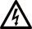**DANGER**

* Do not operate the equipment in any ways other than described in this manual or other related documents. Not following the instructions may cause potential personal injury and/or damage to the property.
* Use the MaxiCharger only as intended.

**NOTE**

The images and illustrations depicted in this manual may slightly differ from the actual product.

This manual will instruct you how to install and operate the MaxiCharger.

## Product Overview (Outside)

1. 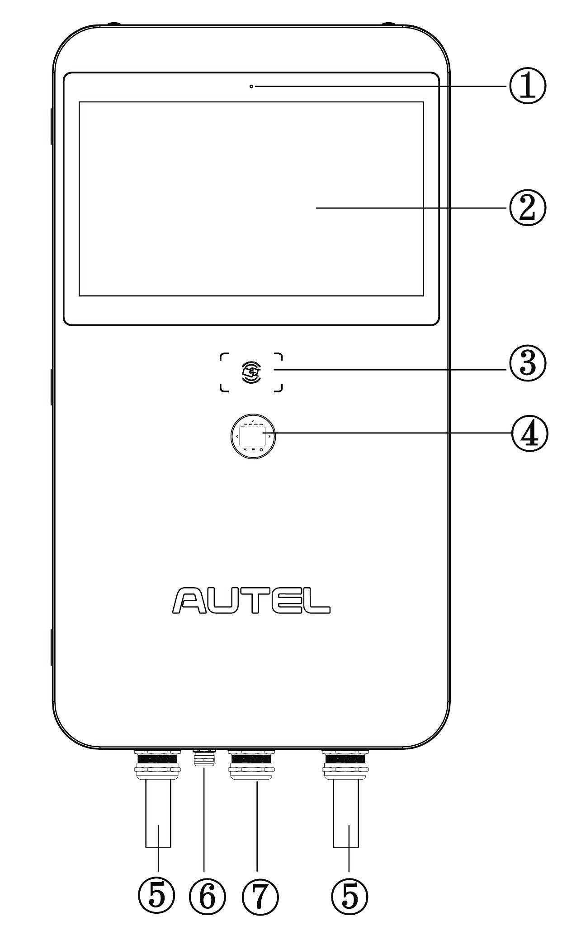Ambient Light Sensor
2. Touchscreen
3. RFID Card Reader
4. POS Payment Device (optional)
5. EV Charging Cable
6. Ethernet Cable Port
7. AC Inlet Hole
8. Vent — each on the right and left side
9. Slot
10. Groove
11. Bezel
12. Lifting Handle

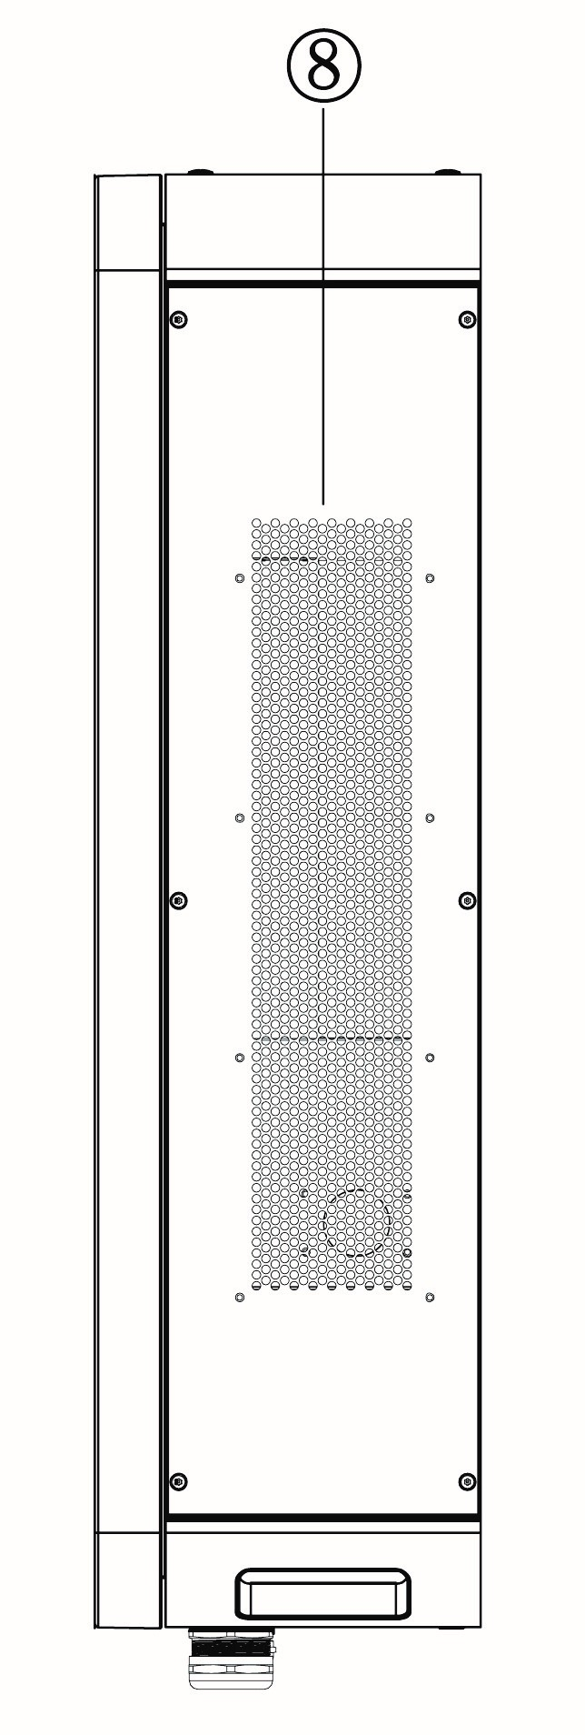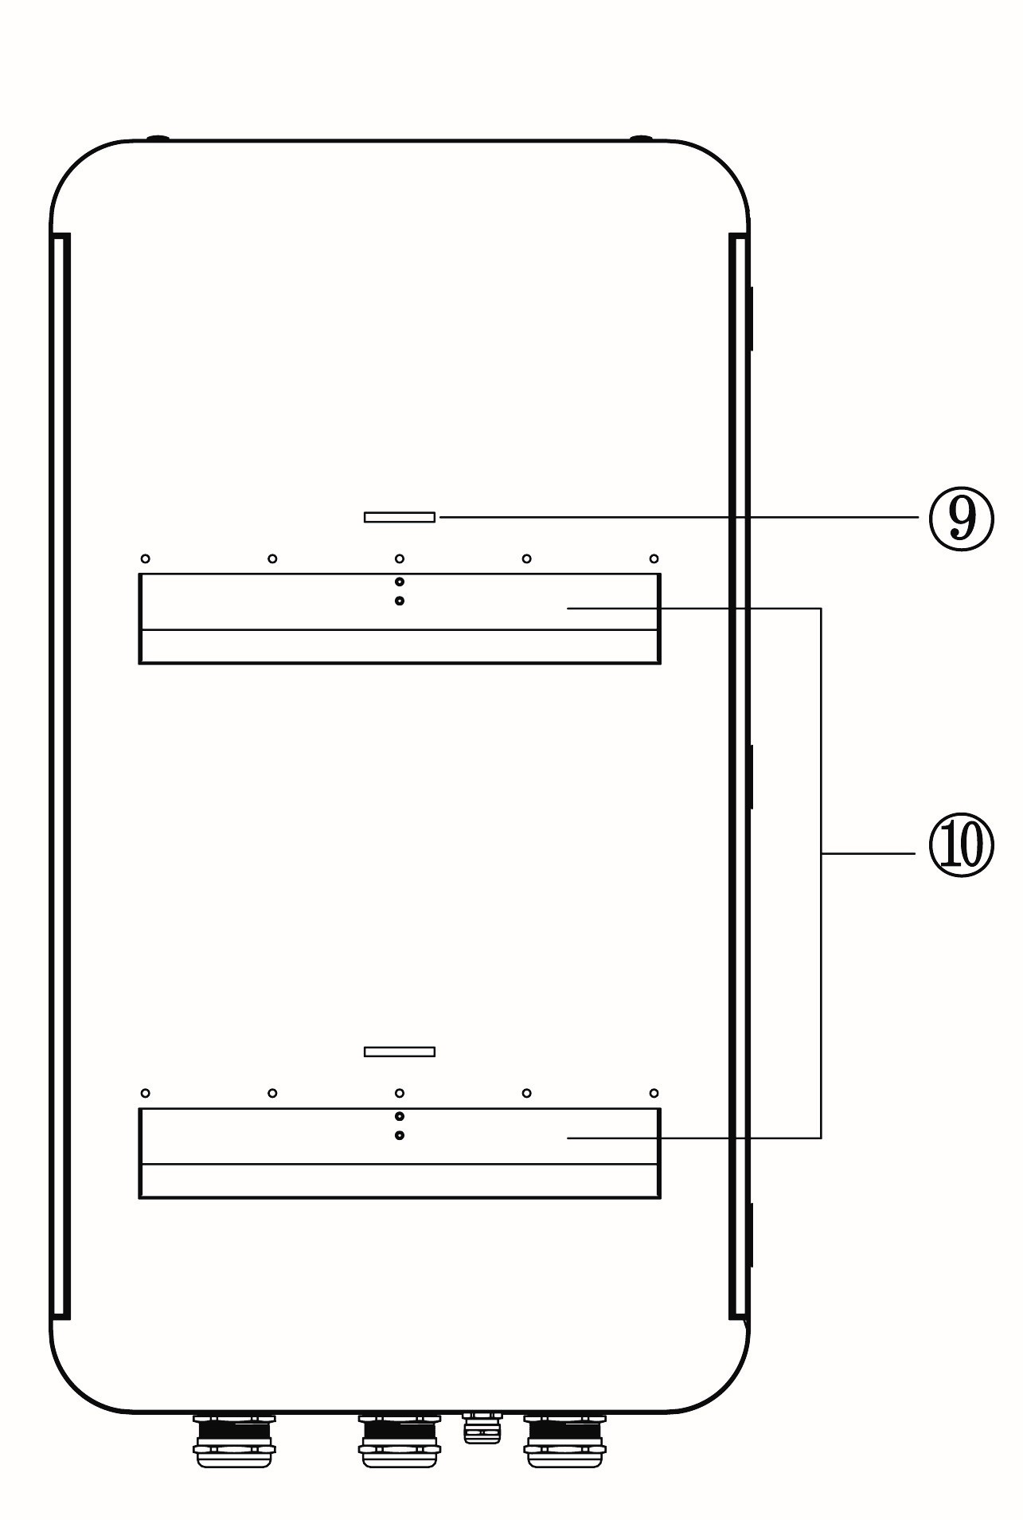

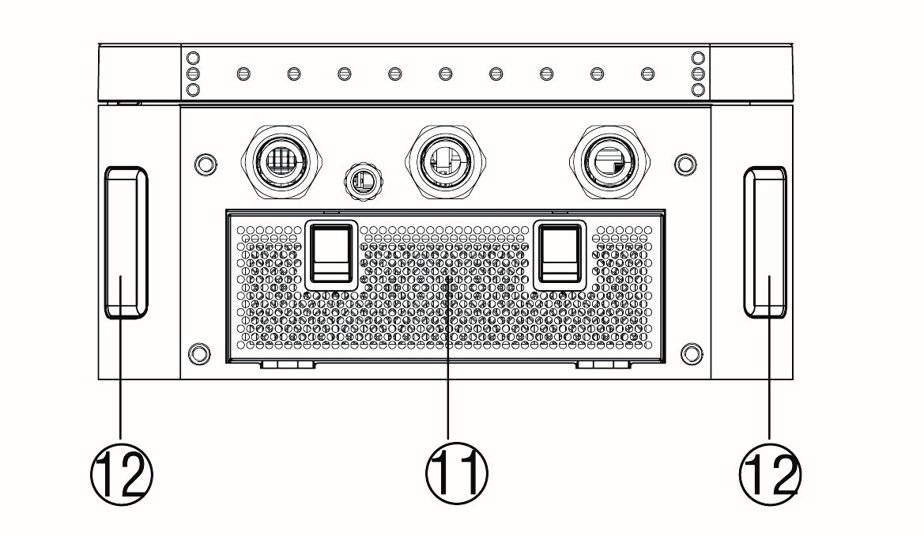

## Product Overview (Inside)

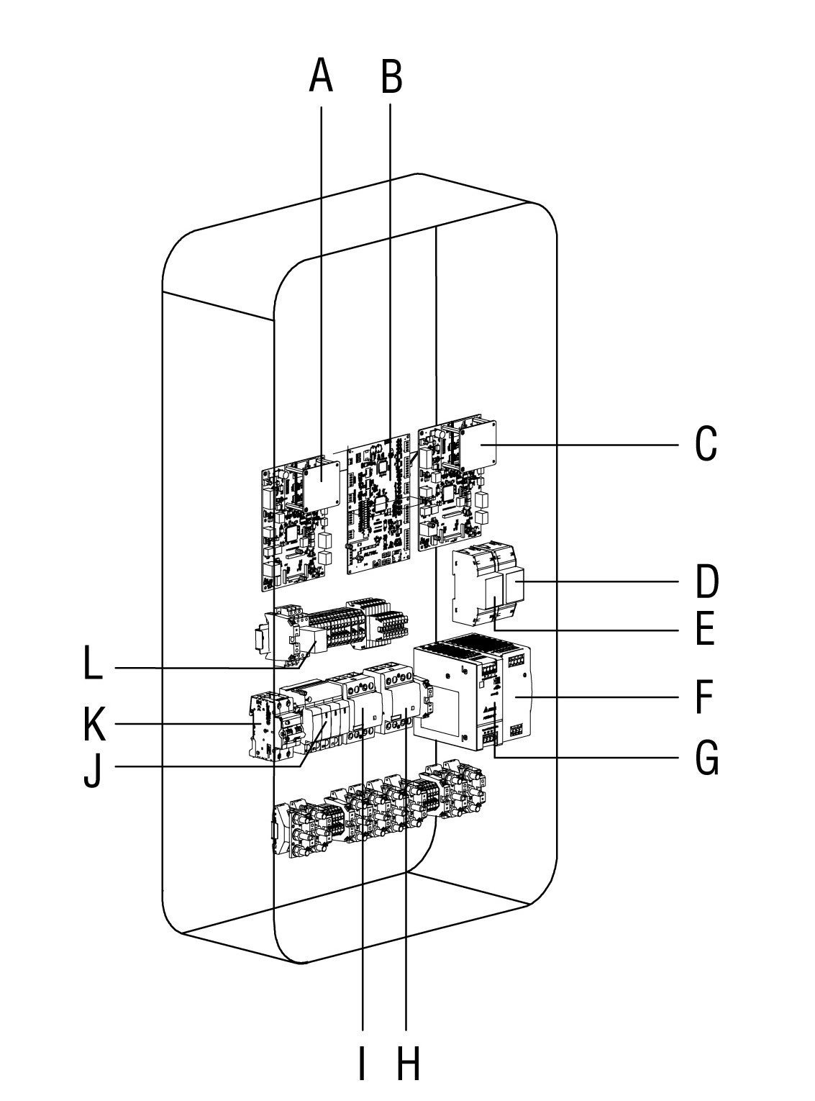

|  |
| --- |
| 1. Communication Control Unit 1 |
| 1. Equipment Control Unit |
| 1. Communication Control Unit 2 |
| 1. Energy Meter (PJ1) |
| 1. Energy Meter (PJ2) |
| 1. 48 V Auxiliary Power |
| 1. 24 V Auxiliary Power |
| 1. AC Contactor (KM2) |
| 1. AC Contactor (KM1) |
| 1. Surge Protection Device |
| 1. Fuse |
| 1. Intermediate Relay |

## Technical Specifications

| Item | Description |
| --- | --- |
| **Product Information** | |
| **Power Rating** | 40 kW, max. 47 kW |
| **Charging Type** | Mode 4 |
| **Max. Output Current for Outlet A/B** | * CCS2: 130 A * CHAdeMO: 125 A |
| **Outlet A+B** | * CCS2 + CHAdeMO (charging for 2 EVs concurrently) * CCS2 + CCS2 (charging for 2 EVs concurrently) |
| **Rated/Max. Input AC Current** | 75 A/82 A |
| **Input Voltage Range** | 400 VAC +10% ~ -10% @ 50Hz |
| **Network Type** | * TN-S (Requires external RCD) * TN-C (Requires external RCD) * TN-C-S (Requires external RCD) * TT (Requires external RCD) |
| **AC Input Connection** | 3P + N + PE |
| **DC Output Voltage** | * CCS2: 150 ~ 950 VDC * CHAdeMO: 150 ~ 500 VDC |
| **Cable Length** | 4 m/7.5 m |
| **Protection** | * Overcurrent * Overvoltage * Under-voltage * Ground Fault * Over-temperature * Short-circuit * Insulation Monitor * Surge Protection |
| **Overvoltage Category** | AC side (Input) OVC: III |
| **Power Factor (>50% load)** | ≥ 0.98 |
| **Total Harmonic Distortion**  **(>50% load)** | ≤ 5% |
| **Peak Efficiency** | ≥ 96% |
| **Standby Power** | 40 W |
| **Cellular Communication** | * GSM * 4G * LTE |
| **General Characteristics** | |
| **Enclosure Rating** | IP54 |
| **Operating Altitude** | < 2000 m (2000 m ~ 3000 m with power de-rating) |
| **Operating Temperature Range** | -30 °C to +55 °C (+45 °C to +55 °C with linear power de-rating) |
| **Storage Temperature Range** | -40 °C to +70 °C |
| **Mounting** | Floor Mount |
| **Dimensions (W x D x H)** | 550 x 265 x 1000 mm |
| **User Interface** | |
| **Status Indication** | LED/APP |
| **User Interface** | * Autel Charge APP * Autel Charge Cloud |
| **Connectivity** | * Wi-Fi * Ethernet * CAN * RS485 * Cellular Network |
| **Communications Protocols** | * OCPP 1.6 JSON * OCPP 2.0.1 (optional) |
| **User Authentication** | * QR Code * RFID * Plug & Charge * Credit Card (optional) |
| **Software Update** | |
| **Software Update** | OTA updates via web portal |
| **Certification and Standards** | |
| **Charging System** | * IEC 61851-1 * IEC 61851-23 * IEC 61851-21-2 |
| **Communication to the EV** | * ISO 15118 * DIN 70121 * CHAdeMO 1.2 |
| **EMC Compliance** | Class A |
| **Certification** | * CE * UKCA |
| **Design Life** | 10 year |
| **Warranty** | Base warranty 24 months after site acceptance test or 30 months after factory delivery. Warranty extensions available. |

# Preparation

## Before You Begin

* Read through this manual prior to installation to familiarize yourself with the installation steps.
* Ensure the appropriate wiring, circuit protection, and metering are in place at the installation site, according to the specifications, wiring diagrams, and grounding requirements.
* Ensure the MaxiCharger is connected to a grounded, metal, permanent wiring system. Otherwise, an equipment-grounding conductor must be run with the circuit conductors and connected to the equipment grounding terminal or lead on the product.
* Ensure the installation site has a load capacity sufficient to support the MaxiCharger.
* If you choose to use a cellular network to communicate with the MaxiCharger, the cellular coverage at the installation site should be consistently strong. Use a cellular signal detection device to ensure the signal is above -90 dBm. If the signal is below -90 dBm, install repeaters to boost the strength of the cellular signal. Repeaters are often required when installing the MaxiCharger in underground environments such as in an underground garage or enclosed parking space.
* There is enough space available around the installation site to use a lifting equipment, to unpack, and to allow people to work freely.
* Ensure the charging connector of the MaxiCharger can sufficiently reach the vehicle’s charging port with the chosen cable length. The standard charging cable length is 4 m, and a 7.5-meter cable is also available.

## Installation Tools

* Flathead Screwdriver
* Hoisting Equipment
* Socket Wrench (8 mm/10 mm/13 mm/19 mm)
* Phillips Screwdriver
* Drill (16 mm)
* Cleaning Tool
* Wire Stripper
* Cable Lug
* Voltage Tester
* Digital Multimeter

**NOTE**

The tools mentioned above are not provided. Be sure to have all the tools prepared prior to the installation.

# Installation

The MaxiCharger DC Wall Mount has four variations available. The installation work shall be carried out after a suitable location is chosen.

|  |  |  |
| --- | --- | --- |
| **No.** | **Variation** | **Overview of Installation Steps** |
| **A** | **MaxiCharger and Pedestal** | 1. Unpacking 2. Moving the MaxiCharger 3. Installing MaxiCharger and Pedestal 4. Power Supply Wiring 5. Completing the Installation |
| **B** | **MaxiCharger mounted on Pedestal** | 1. Unpacking 2. Moving the MaxiCharger 3. Installing MaxiCharger Mounted on Pedestal 4. Power Supply Wiring 5. Completing the Installation |
| **C** | **MaxiCharger and Trolley** | 1. Unpacking 2. Moving the MaxiCharger 3. Installing MaxiCharger and Trolley 4. Power Supply Wiring 5. Completing the Installation |
| **D** | **MaxiCharger mounted on Trolley** | No electrical and mechanical installation is needed for the MaxiCharger mounted on trolley. |

**NOTE**

* The MaxiCharger and Pedestal means MaxiCharger and Pedestal will be shipped in separate boxes.
* The MaxiCharger mounted on Pedestal means the MaxiCharger has been installed on a pedestal before shipment.
* The MaxiCharger and Trolley means MaxiCharger and Trolley will be shipped in separate boxes.
* MaxiCharger mounted on Trolley means the MaxiCharger has been installed on a trolley before shipment.

**CAUTION**

* Cut off the power supply before opening the MaxiCharger.
* Do not touch the inside components of the MaxiCharger while it is powered on.
* Ensure no voltage is applied while checking the MaxiCharger.
* Operate the MaxiCharger only when its door is closed and locked.

**IMPORTANT**

Always check local codes to ensure compliance. The guidelines described here are the minimum requirements. Ensure that the installation complies with all applicable codes.

## Unpacking

1. Check the tilt and inversion indicators and shock watch.

* Observe the sensors attached to the wooden box for the degree of the tilt and complete overturn. If the sensors demonstrate severe tilt (over 30°) or total overturn as shown, do not refuse shipment and note on bill of lading degree of tilt.

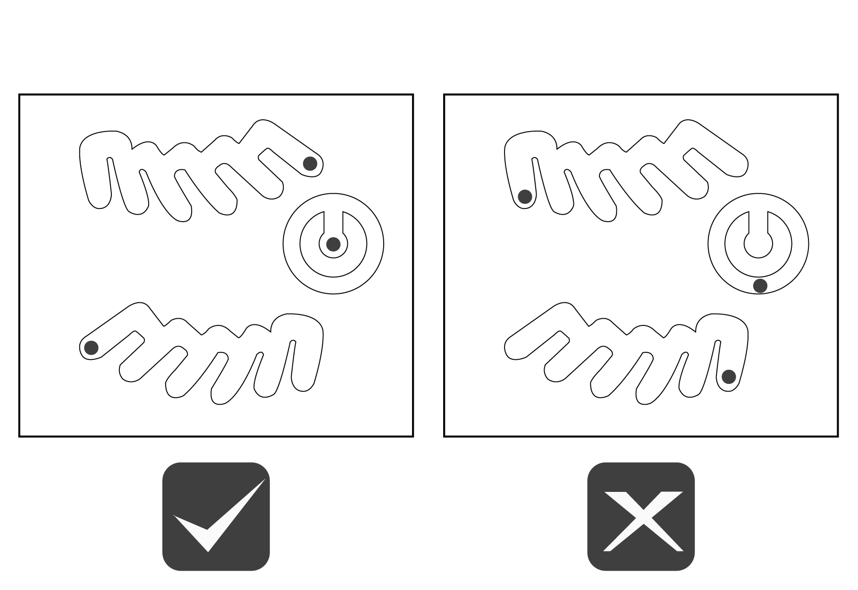

* If the shock watch appears red, contact Autel customer service and the delivery personnel.

1. Remove the packaging material using appropriate tools.
2. Inspect whether the MaxiCharger and the parts for installation are damaged. If any damage is found or the parts are not consistent with the order, contact your local dealer.
3. Make sure that all parts are delivered according to the order.

## Moving the MaxiCharger

It is recommended to move the MaxiCharger to the installation site using an appropriate hoisting equipment (crane, straps, and so on).

1. Remove the four screws on the top of the charger using a flathead screwdriver. Set them aside.

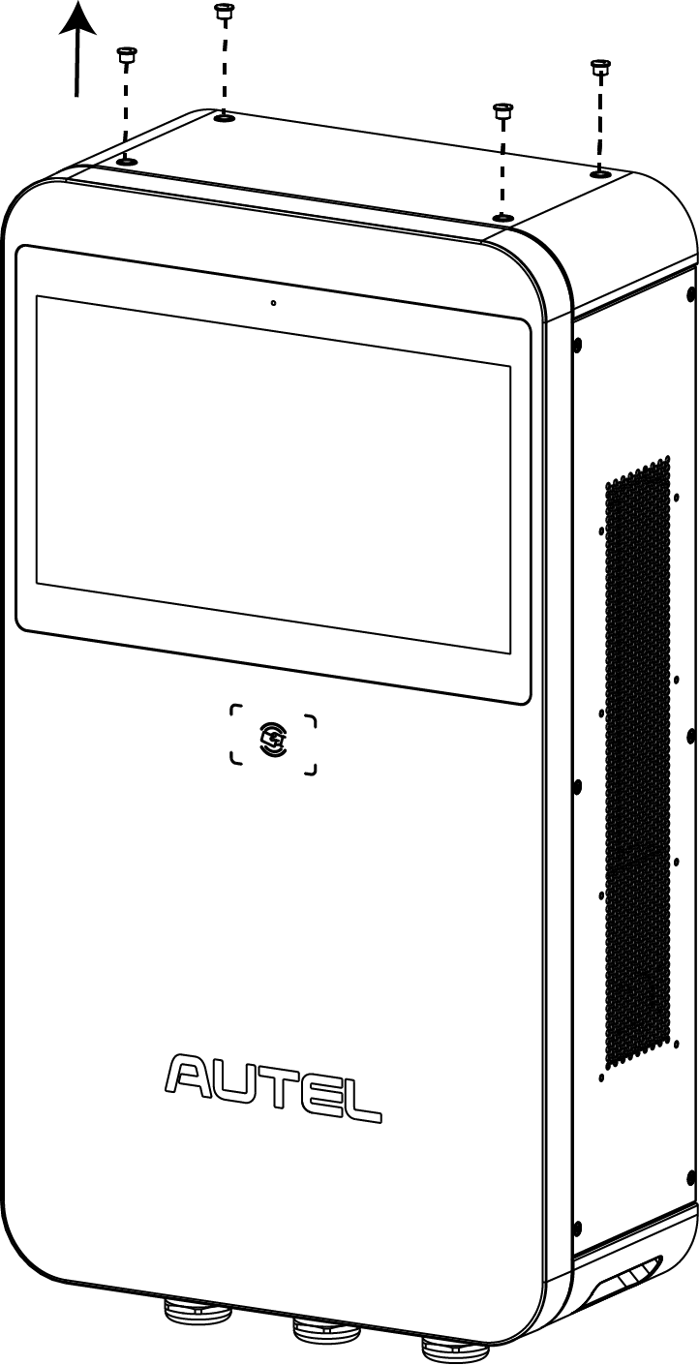

1. Install and tighten the four M12 lifting eye bolts into the four holes.
2. Connect the cables of the hoisting equipment to the eye bolts’ lifting loops. Do not tilt over 45° when hoisting the MaxiCharger.
3. Move the MaxiCharger to the installation site.

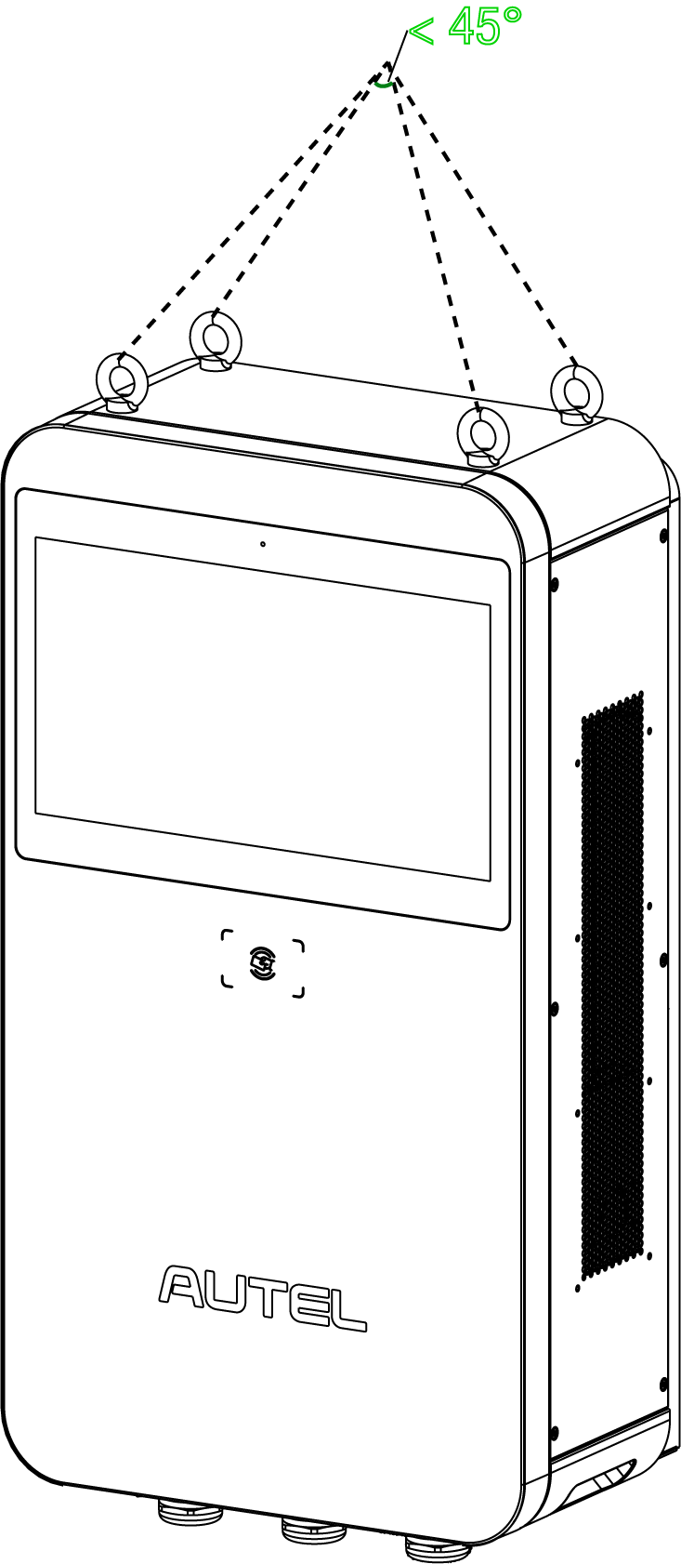

## Installing MaxiCharger and Pedestal

**Location Requirements**

The pedestal can be installed on an existing concrete. To safely mount the equipment, the concrete should be at least **80 mm** thick and its surface should be perfectly flat and level.

**If a new foundation is required, prepare one according to the recommended dimensions (600 mm x 420 mm x 100 mm) (W x D x H).**

**NOTE**

The foundation is recommended to be flush with the surface.

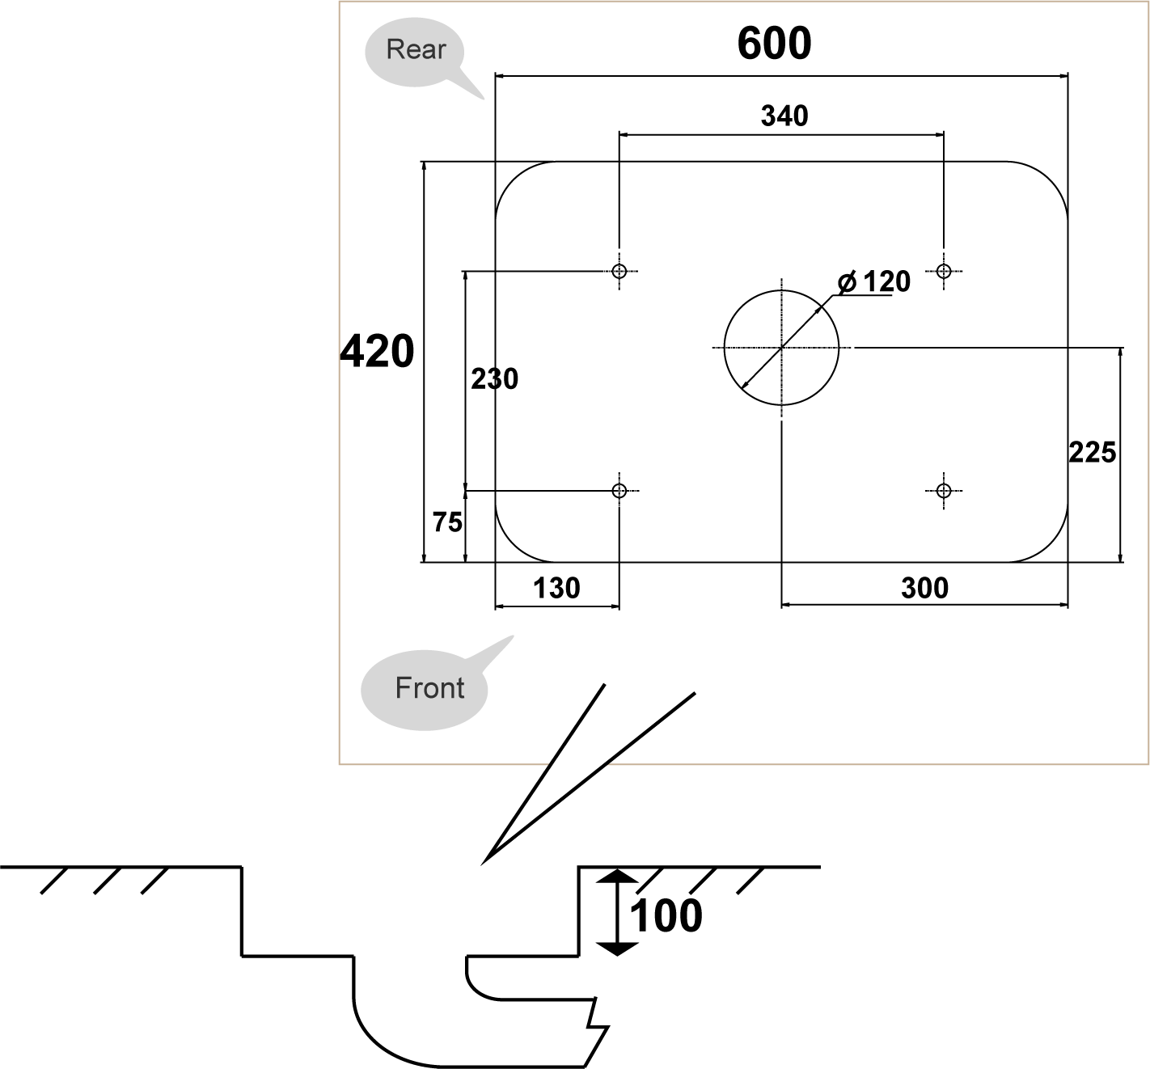**Unit: mm**

**Checking the Package**

Ensure the following items can be found in the package.

|  |  |  |  |
| --- | --- | --- | --- |
| **MaxiCharger** |  | **Lifting Eye Bolt (M12)**  (4 PCS) |  |
| **Torx Screwdriver (T25)** |  | **Hex Key (6 mm)** |  |
| **Screw (M5 x 20) (For spare use)**  (4 PCS) |  | **Drilling Template** |  |
| **Pedestal** |  | **Expansion Bolt (M12 x 80** **)**  (4 PCS) |  |
| **Screw (M12 x 30)**  **(2 PCS for spare)**  (4 PCS) |  |  |  |

**Getting Started**

**Step 1: Preparing the conduit**

1. Trench and excavate a cable tunnel to accommodate the conduit. The outer diameter of the conduit must not exceed 120 mm.
2. The conduit stub-up should be minimum 100 mm.
3. Pull the conduit and wire up through the exit opening, leaving 600 mm flexible length for the remaining installation activities.

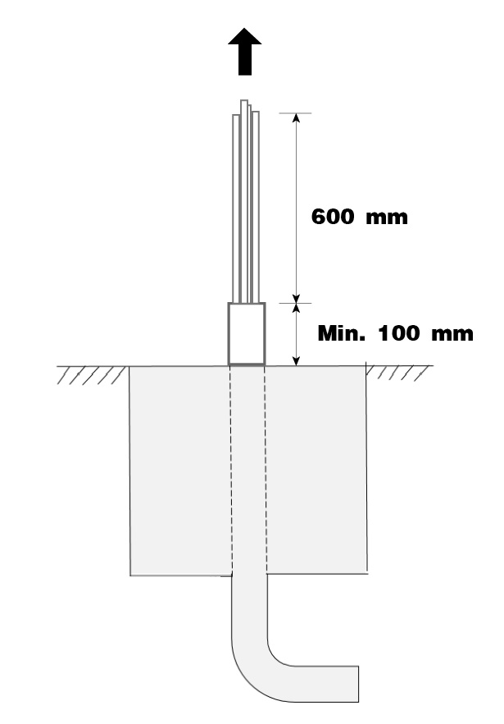

**Step 2: Drilling holes**

1. Place the drilling template on the concrete surface, aligning its central hole with the exit opening.

**NOTE**

The “Front” side of the drilling template must face forward.

1. Mark four holes on the concrete surface using a marker. Remove the drilling template.
2. Drill four holes at the marked positions measuring 16 mm in diameter and minimum 80 mm in depth.
3. Clean the ashes.

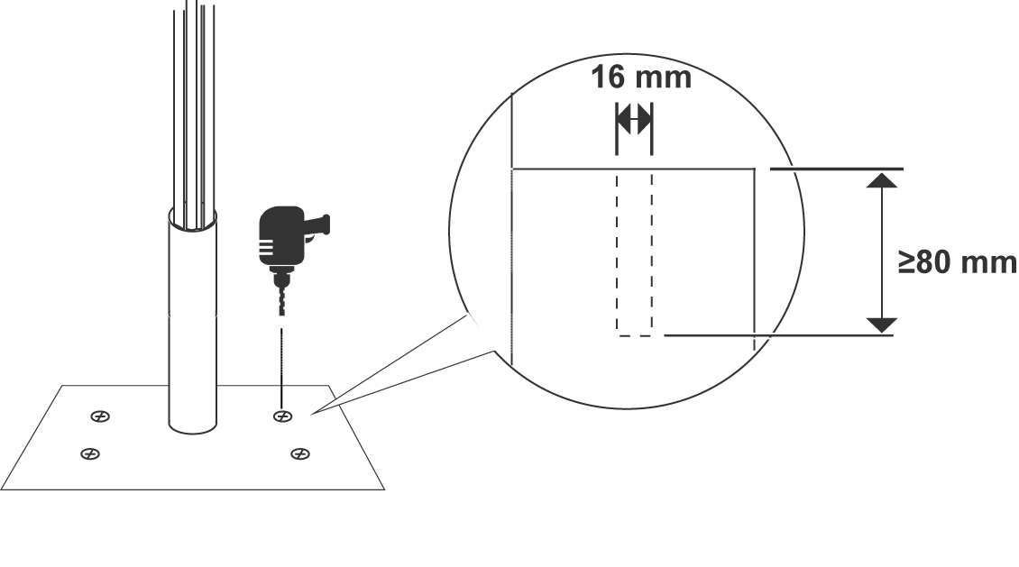

**Step 3: Mounting a pedestal**

1. Screw the four M12 x 80 expansion bolts into the drilled holes. Remove the threaded bolts (**C**) and flat washers (**B**) when the expansion sleeves (**A**) are stuck. Set them aside.

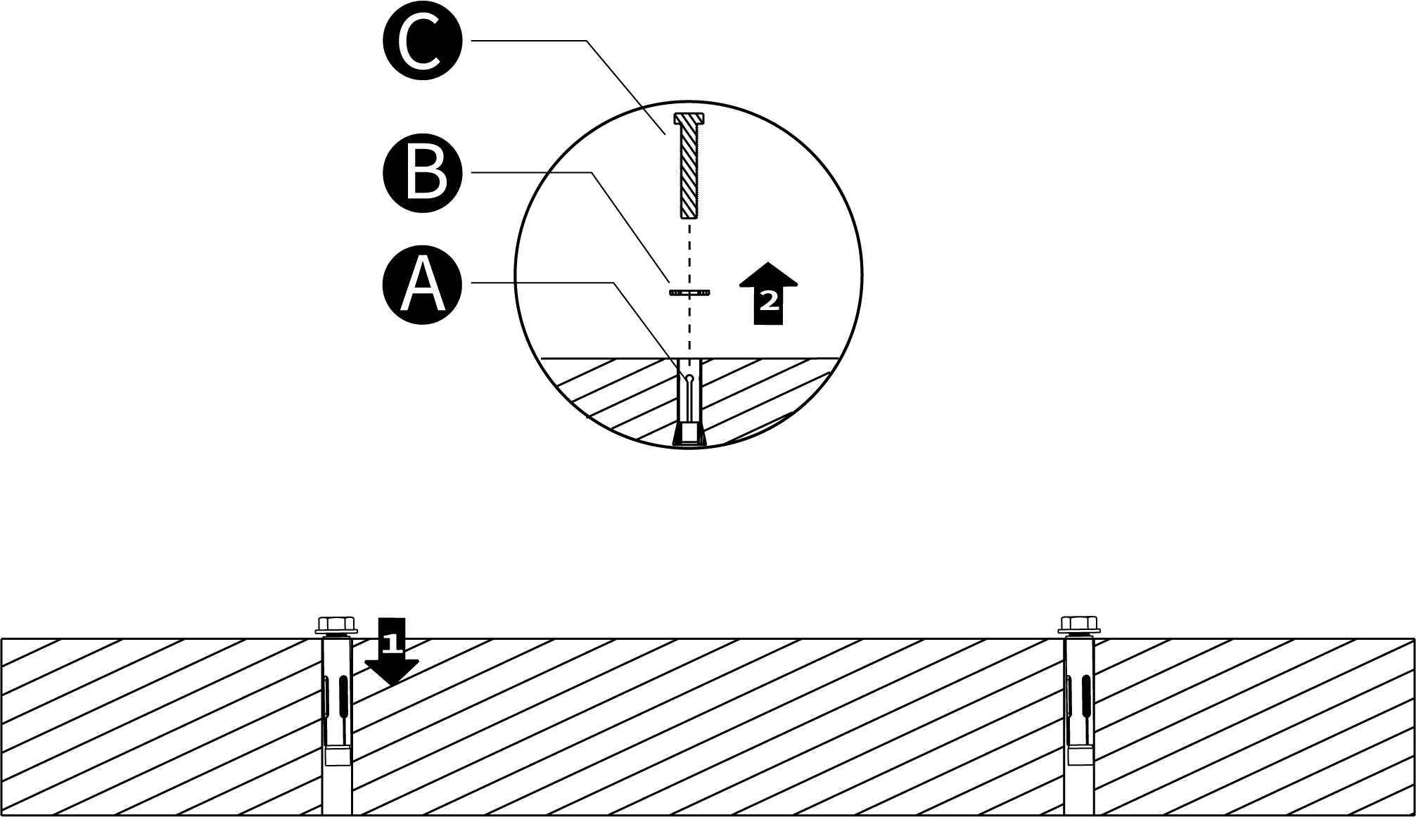

1. Loosen the four M5 x 12 screws using the T25 Torx screwdriver to remove the front cover from the pedestal. Set them aside.

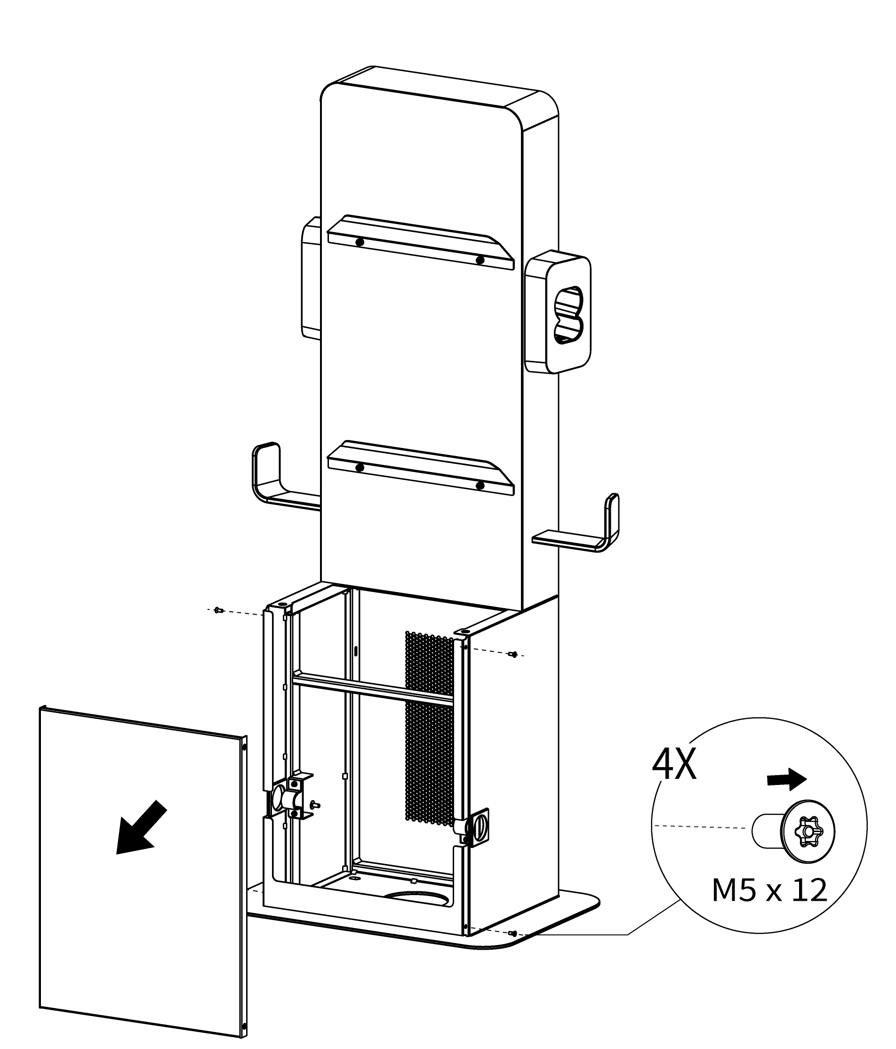

1. Place the pedestal onto the mounting location, aligning the central hole with the exit opening.
2. Reinsert the flat washers and threaded bolts in order and tighten them using a 19 mm socket wrench to 45–55 Nm.

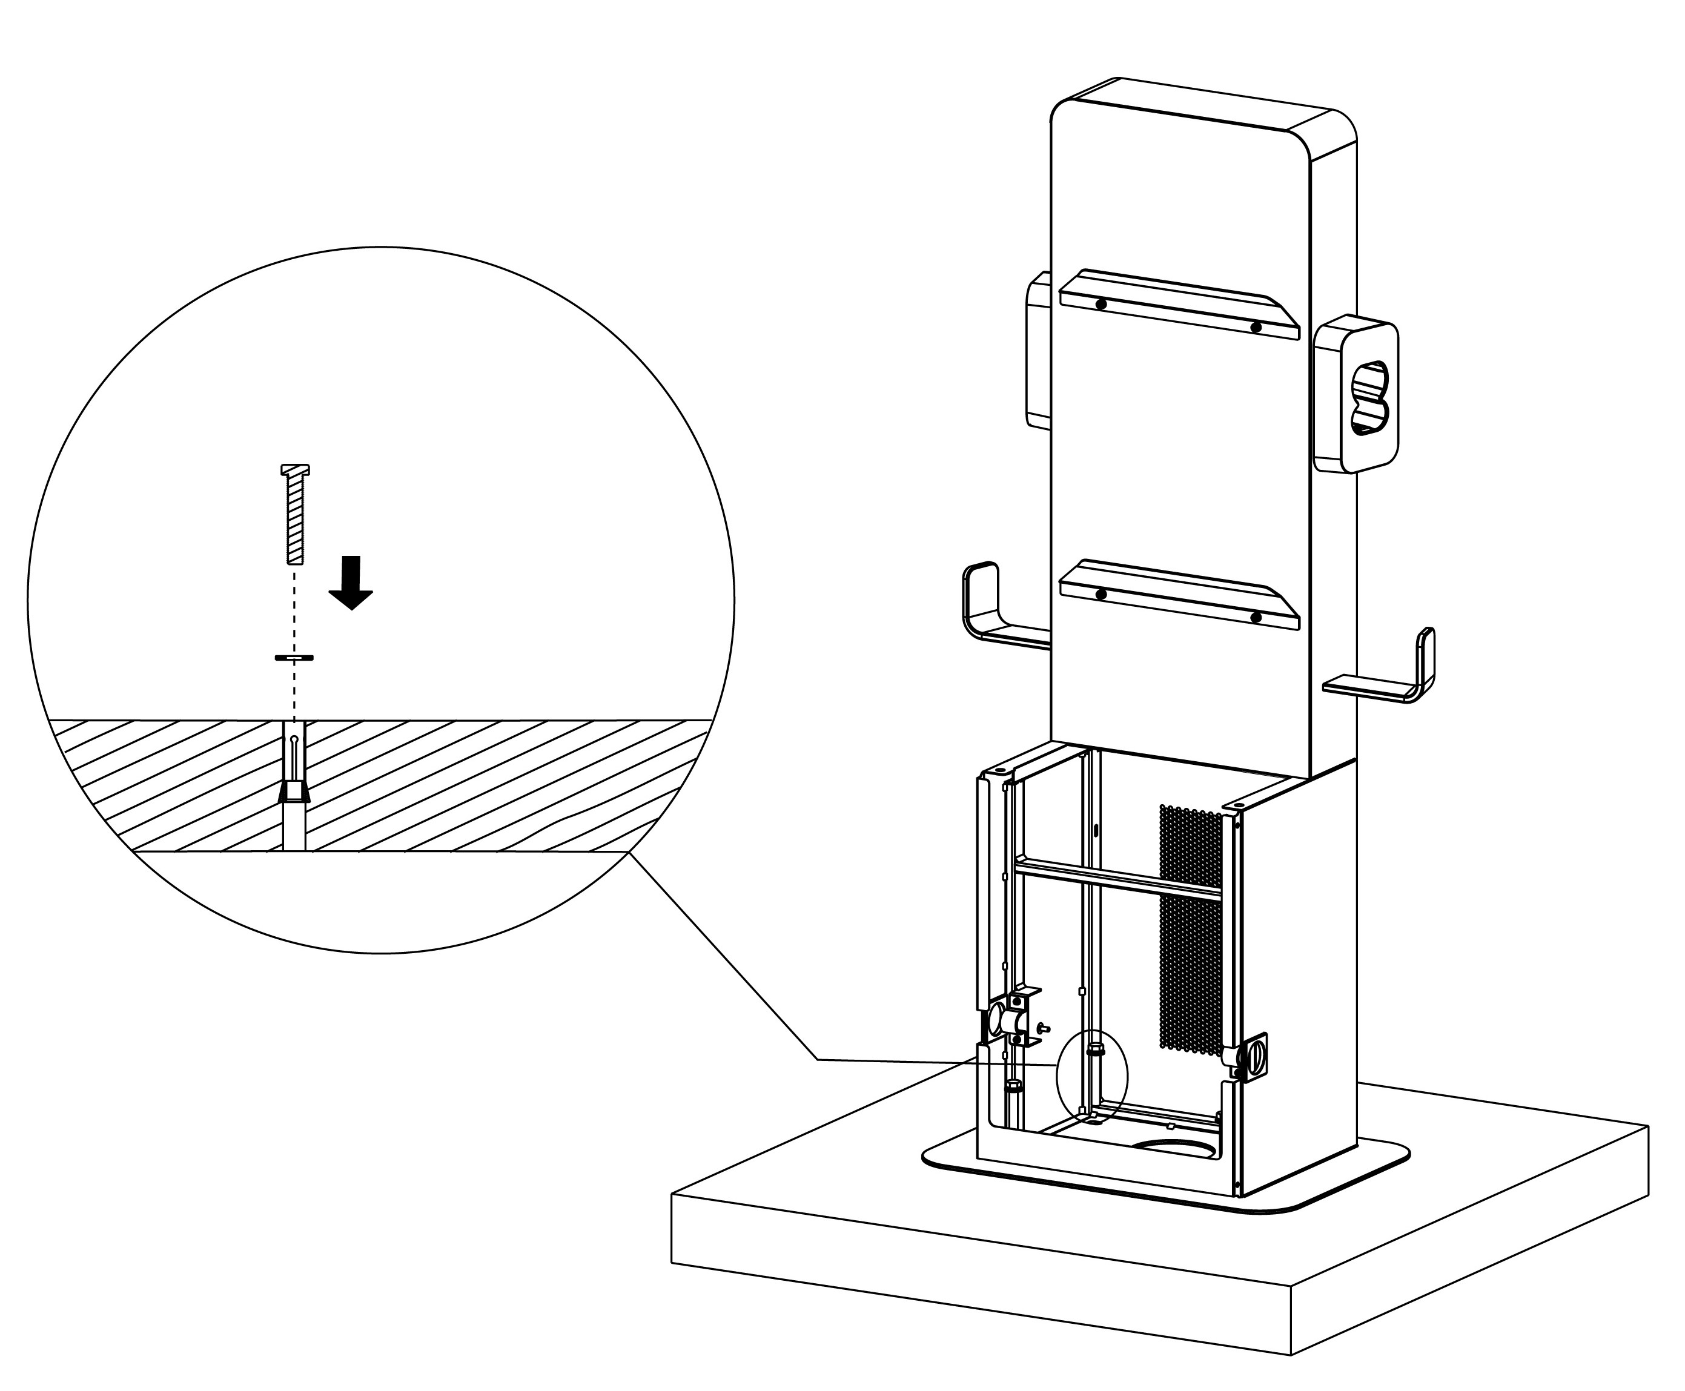

**Step 4: Mounting the MaxiCharger**

1. Lift the MaxiCharger onto the pedestal by the hoisting equipment. Position the groove (**B**) on the back of the MaxiCharger to fit the protrusion (**A**) of the pedestal as shown below. Ensure the charger is securely attached.

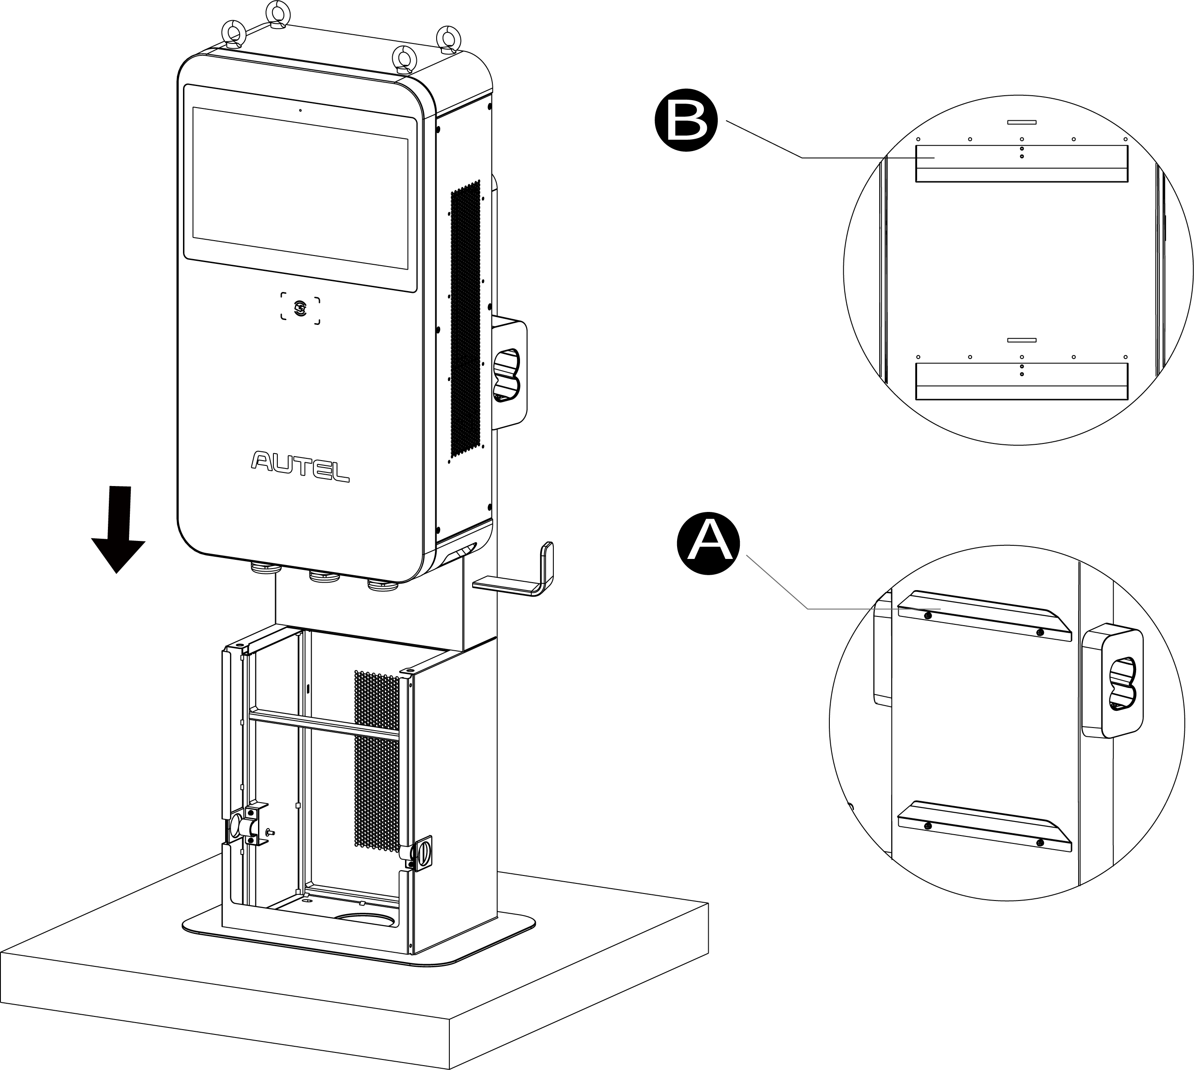

1. Insert and fasten the two M12 x 30 screws to the bottom holes (**A**) of the MaxiCharger using a 19 mm socket wrench to secure the MaxiCharger.

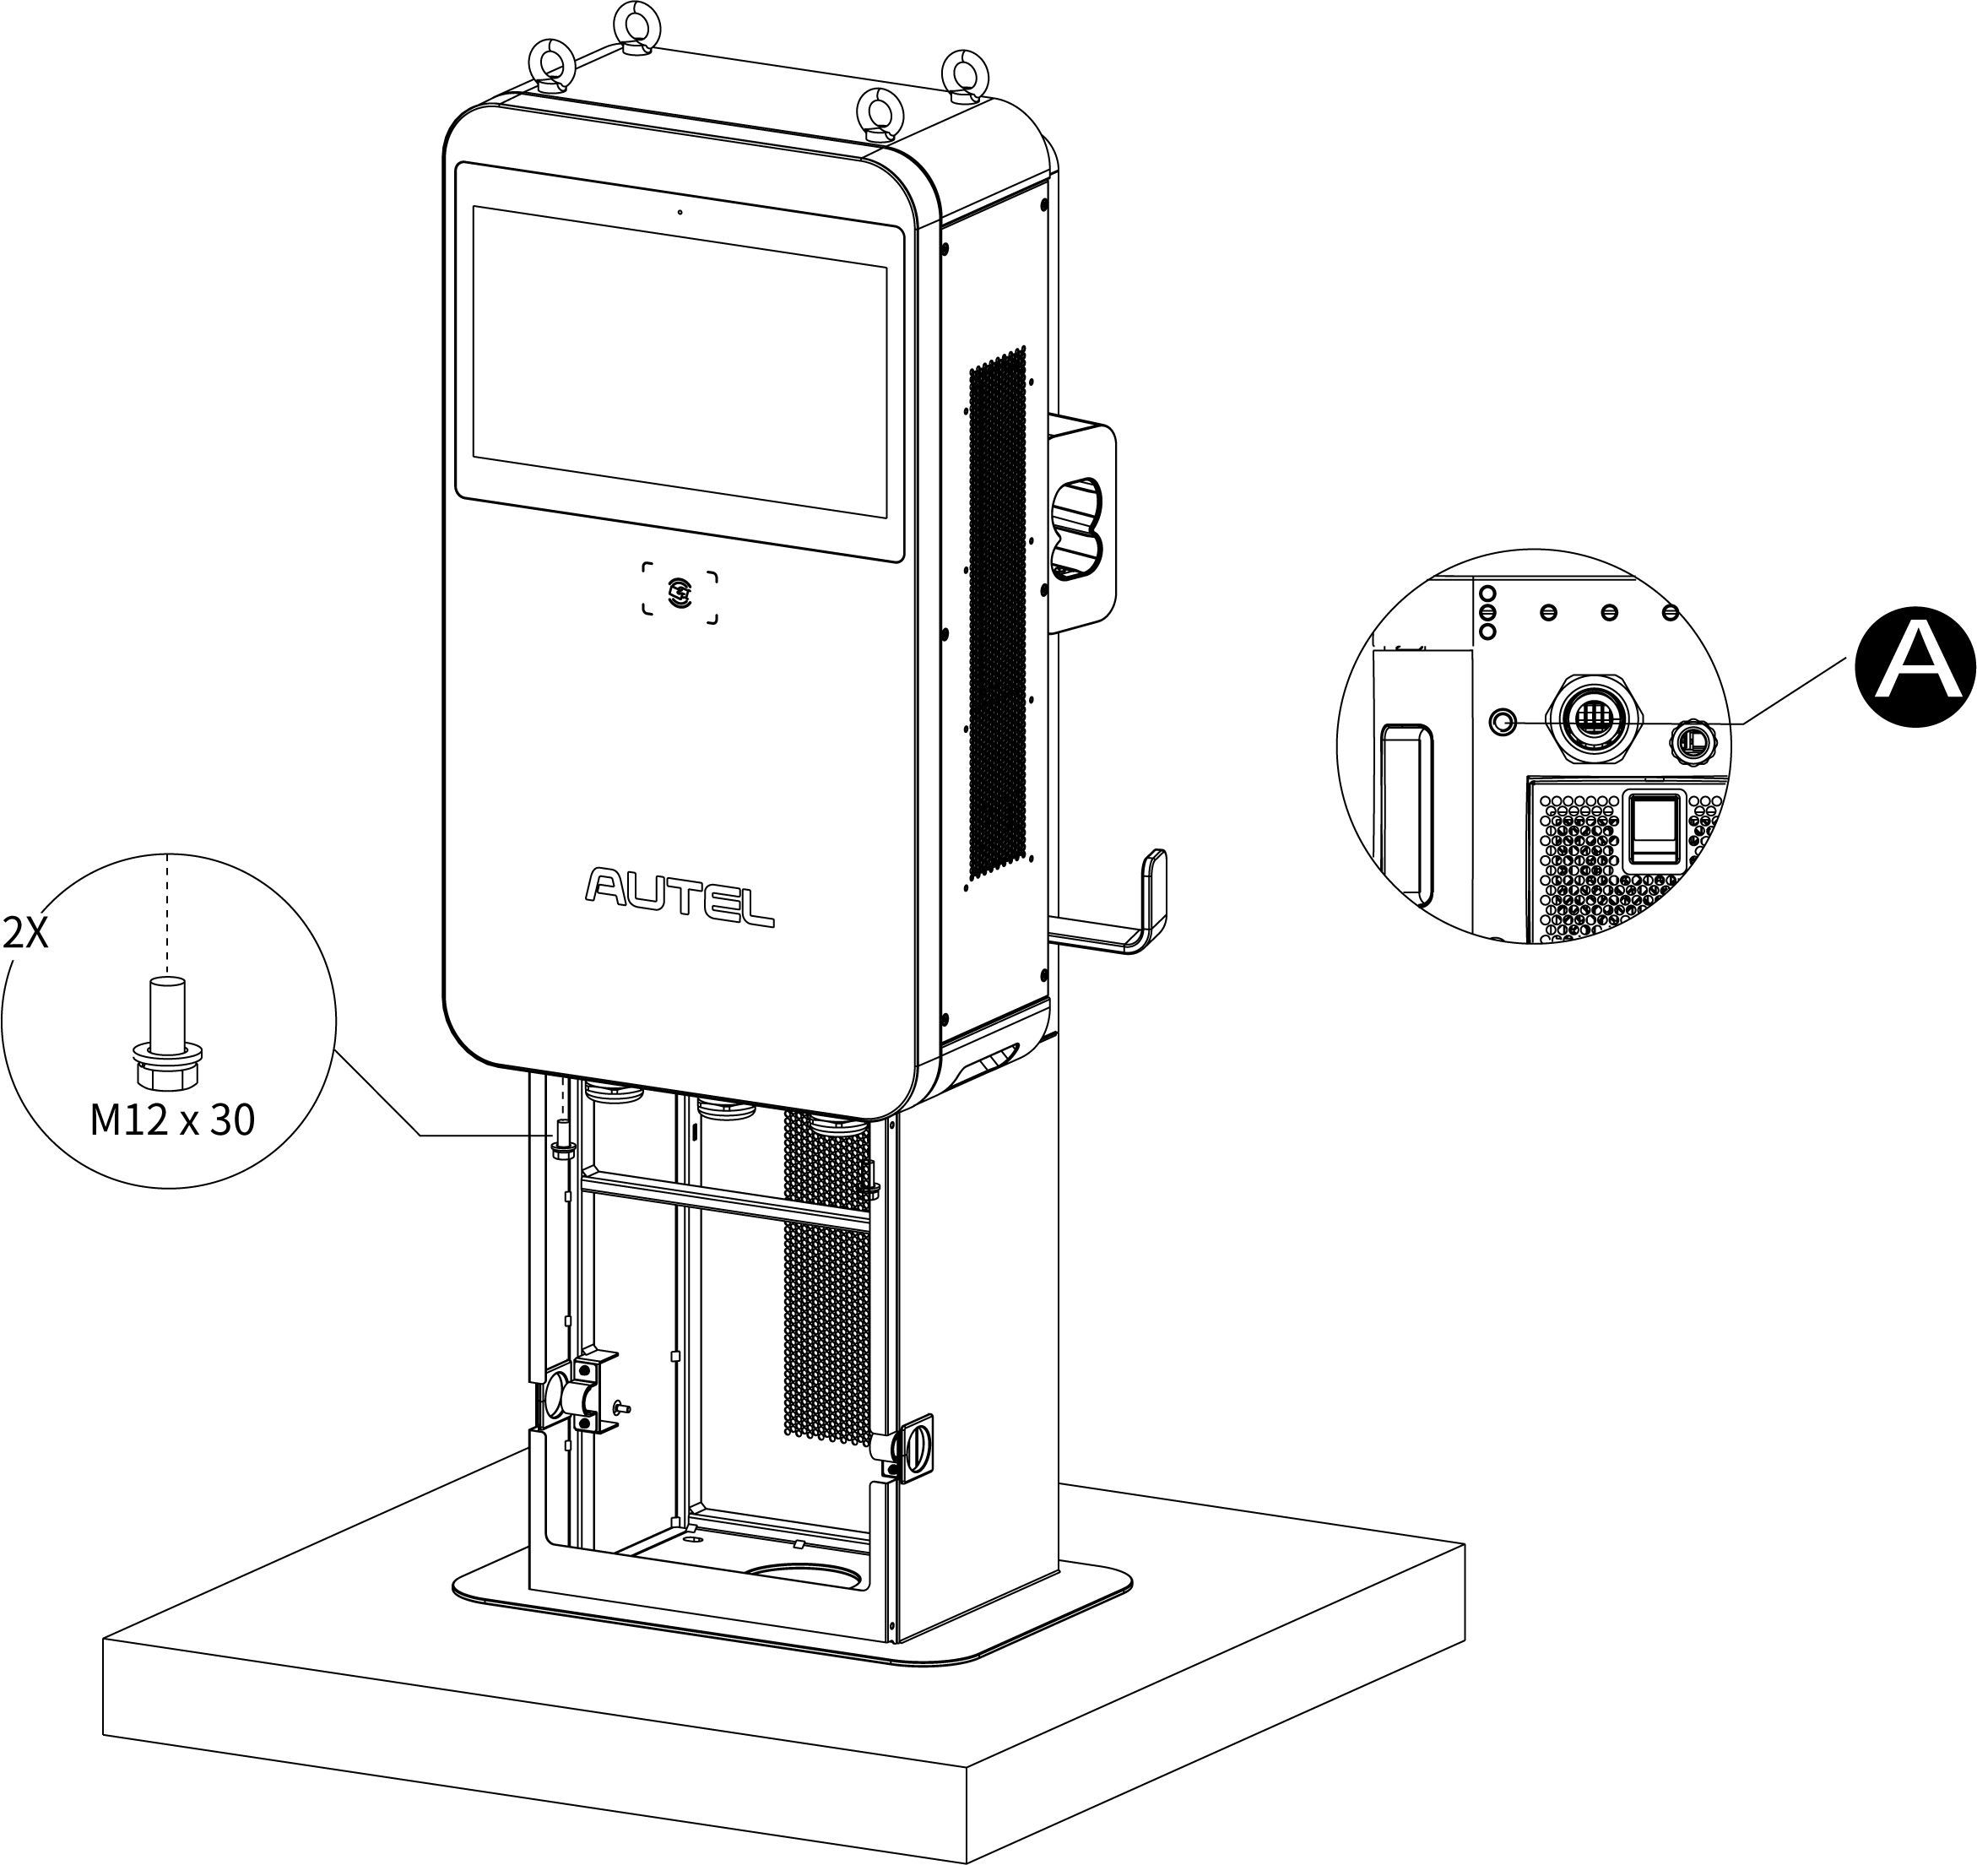

1. Remove the four lifting eye bolts and reinstall the top screws.

**Step 5: Organizing the charging cable**

1. Remove the two strain reliefs (**A**) by unscrewing the four M4 nuts using the Phillips screwdriver and take down the two rubber rings (**B**) from the pedestal.
2. Use the strain reliefs (**A**) to secure the charging cables by screwing the four M4 nuts and tightening them to 1.2 Nm. Install the rubber rings onto the pedestal letting the cables into the rubber rings (**B**) via the openings. Ensure the charging cables are allowed to remain within its bending tolerance.

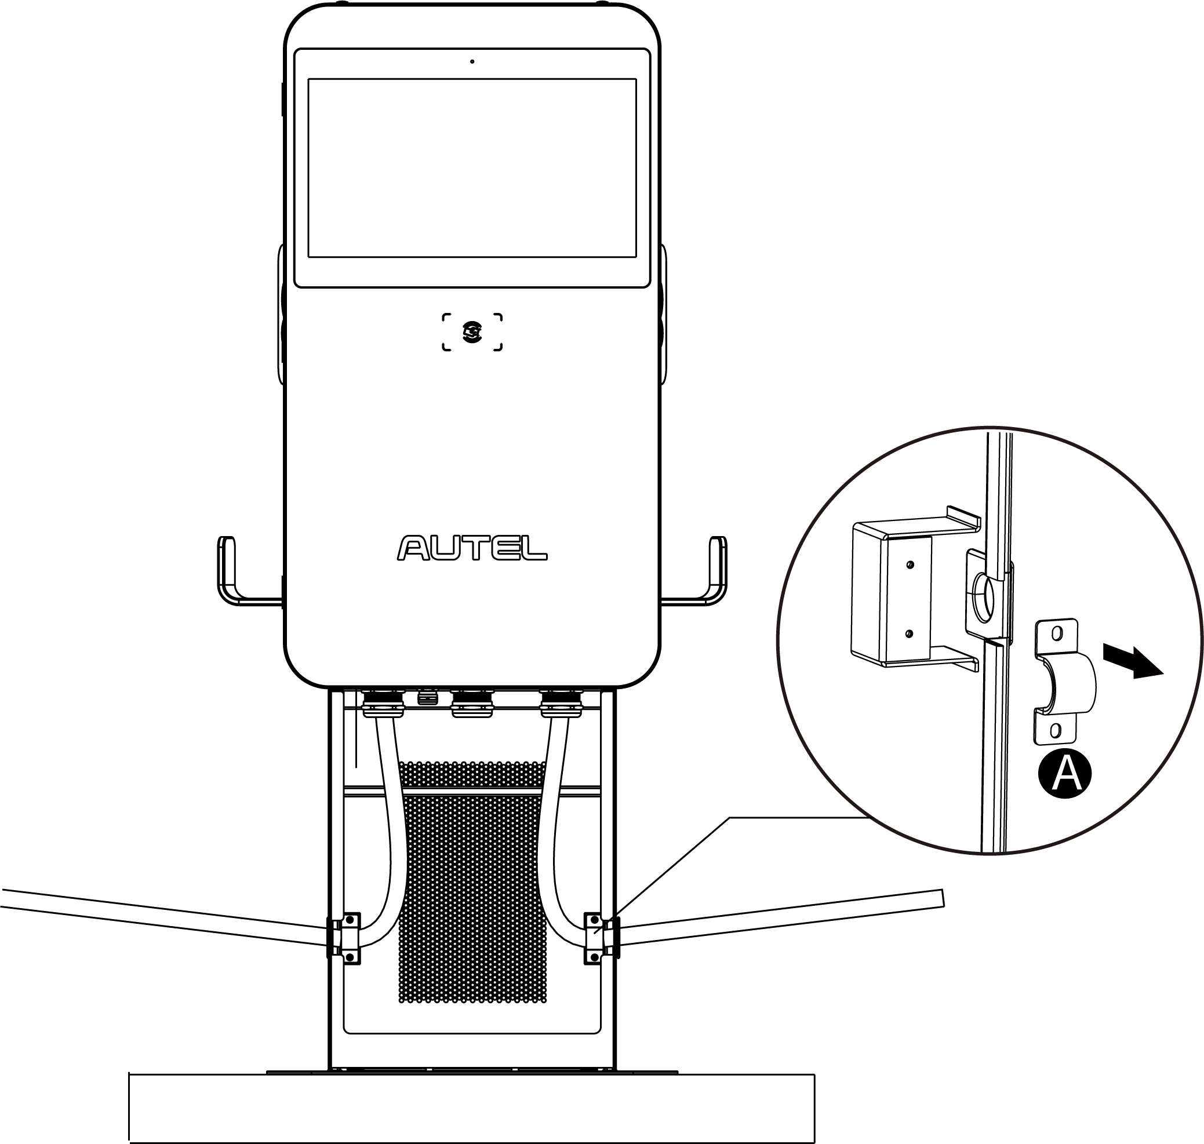

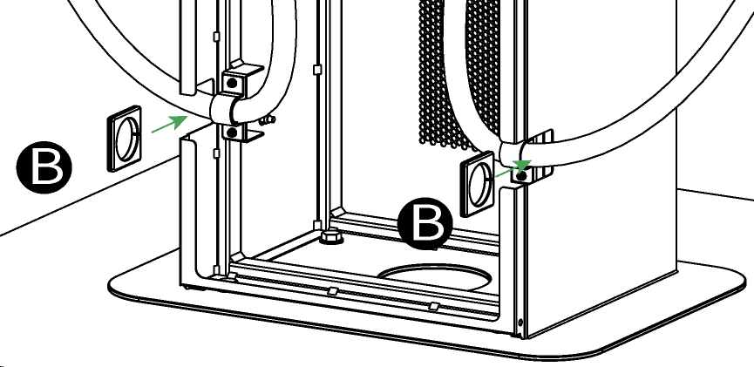

1. Drape the cables over the cable holders on both sides of the pedestal and plug the connectors into the holsters.

After the above installation steps are finished, you are ready to start power supply wiring. Please refer to ***Section 5.6*** to proceed.

**Completing the Installation**

1. Close the front door by reinstalling the two M8 hex screws using the hex key and tightening the screws.
2. Reinstall the side cover (**A**) by inserting and tightening the six M5 x 20 screws to 2 Nm using the T25 Torx screwdriver.

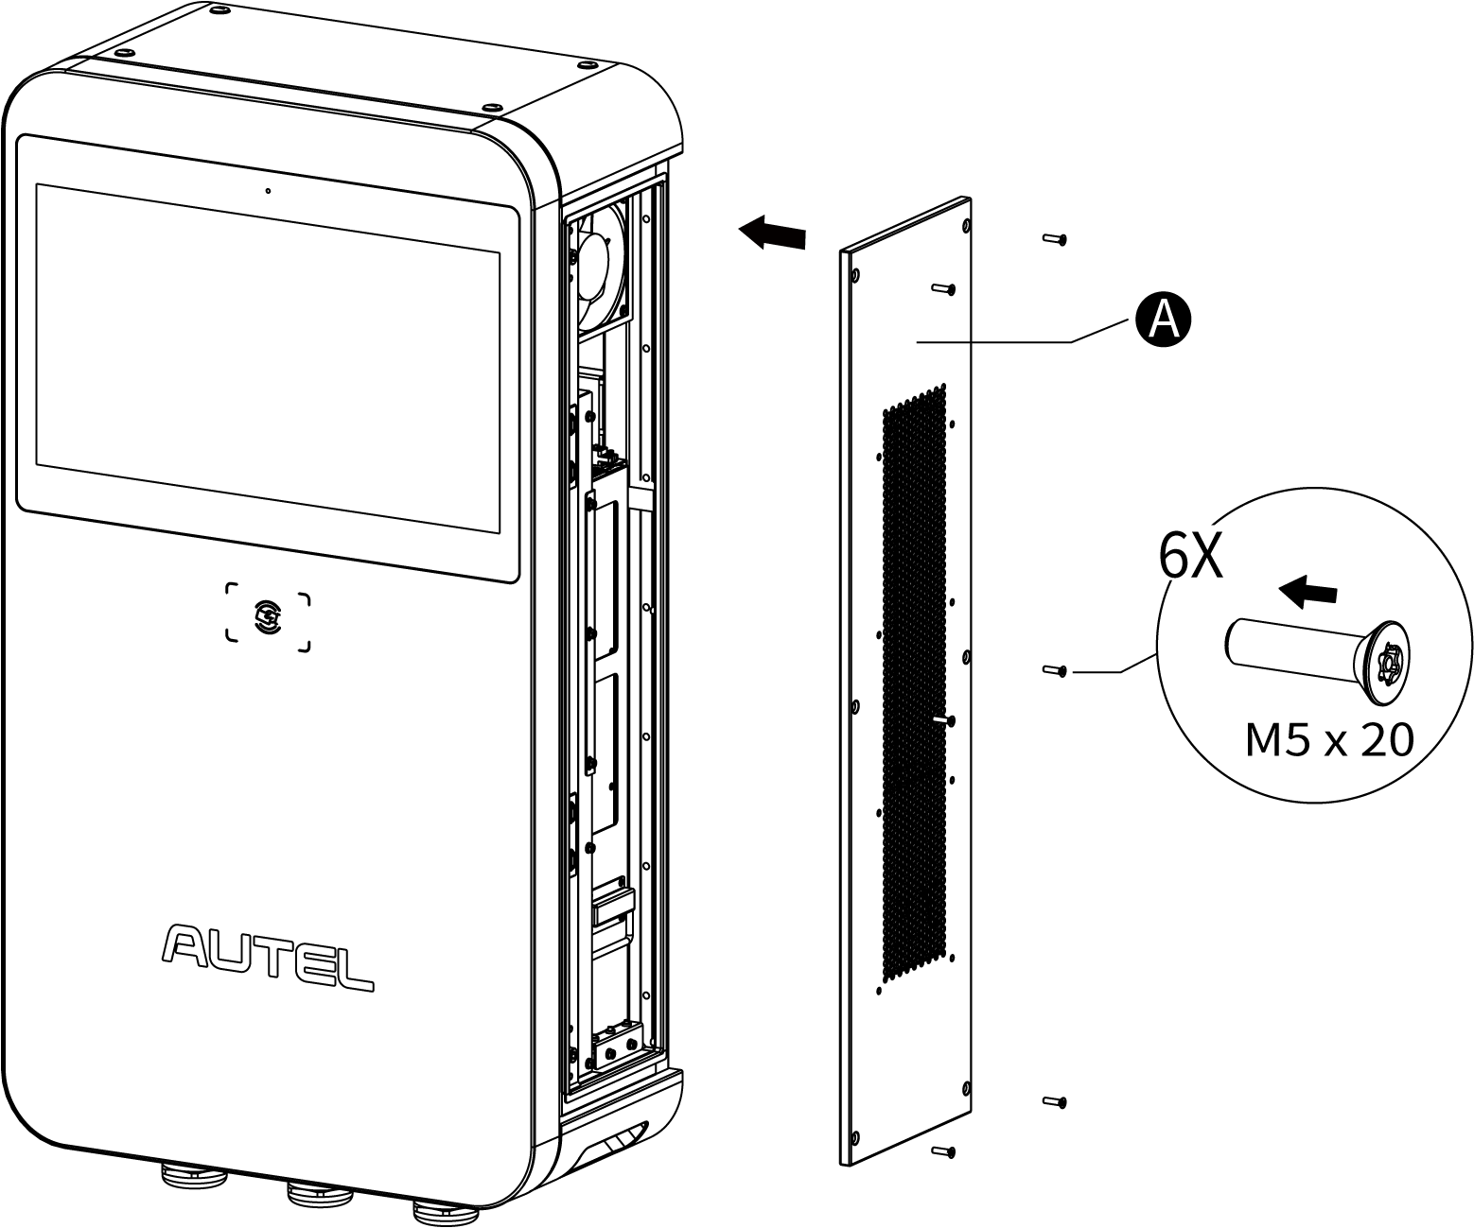

1. Reinstall the pedestal’s front cover by screwing the four M5 x 12 screws and tightening them to 2 Nm.

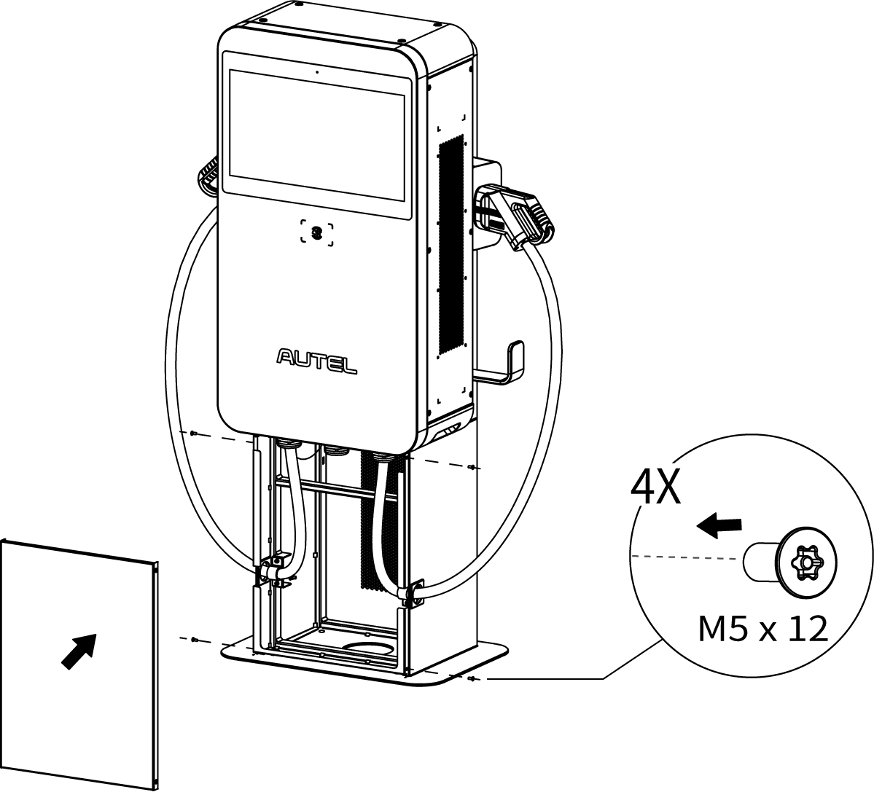

## Installing MaxiCharger Mounted on Pedestal

**Location Requirements**

The pedestal can be installed on an existing concrete. To safely mount a MaxiCharger, the concrete should be at least **80 mm** thick and its surface should be perfectly flat and level.

**If a new foundation is required, prepare one according to the recommended dimensions (600 mm x 420 mm x 100 mm) (W x D x H).**

**NOTE**

The foundation is recommended to be flush with the ground surface.

**Unit: mm**

**Checking the Package**

Ensure the following items can be found in the package.

|  |  |  |  |
| --- | --- | --- | --- |
| **Main Unit** |  | **Lifting Eye Bolt (M12)**  (4 PCS) |  |
| **Torx Screwdriver (T25)** |  | **Hex Key (6 mm)** |  |
| **Expansion Bolt (M12 x 80** **)**  (4 PCS) |  | **Screw (M5 x 20) (For spare use)**  (4 PCS) |  |
| **Drilling Template** |  |  |  |

**Getting Started**

**Step 1: Preparing the conduit**

1. Trench and excavate a cable tunnel to accommodate the conduit. The outer diameter of the conduit must not exceed 120 mm.
2. The conduit stub-up should be minimum 100 mm.
3. Pull the conduit and wire up through the exit opening, leaving 600 mm flexible length for the remaining installation activities.



**Step 2: Drilling holes**

1. Place the drilling template on the concrete surface, aligning its central hole with the exit opening.

**NOTE**

The “Front” side of the drilling template must face forward.

1. Mark four holes on the concrete surface using a marker. Remove the drilling template.
2. Drill four holes at the marked positions measuring 16 mm in diameter and minimum 80 mm in depth.
3. Clean the ashes.



**Step 3: Removing the front cover**

Loosen the four M5 x 12 screws using the T25 Torx screwdriver to remove the front cover from the pedestal. Set them aside.

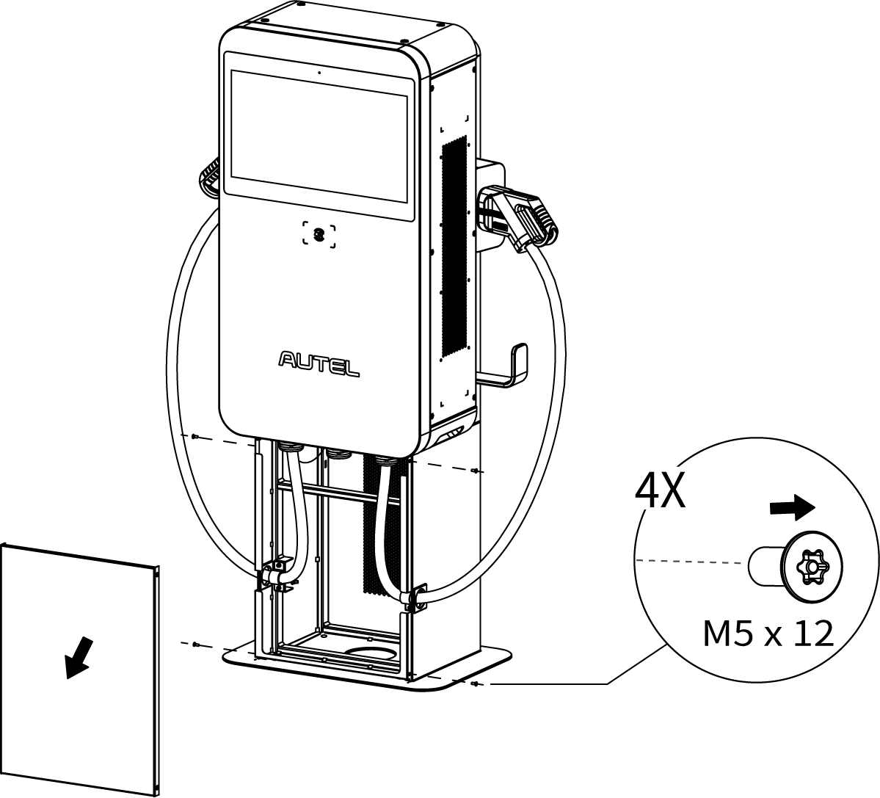

**Step 4: Mounting the MaxiCharger mounted on pedestal**

1. Screw the four M12 x 80 expansion bolts into the four drilled holes. Remove the threaded bolts (**C**) and flat washers (**B**) when the expansion sleeves (**A**) are stuck. Set them aside.



1. Lift the MaxiCharger with pedestal onto the mounting location by the hoisting equipment.
2. Reinsert the flat washers and threaded bolts in order and tighten them using a 19 mm socket wrench to 45–55 Nm.
3. Remove the four lifting eye bolts and reinstall the top screws.

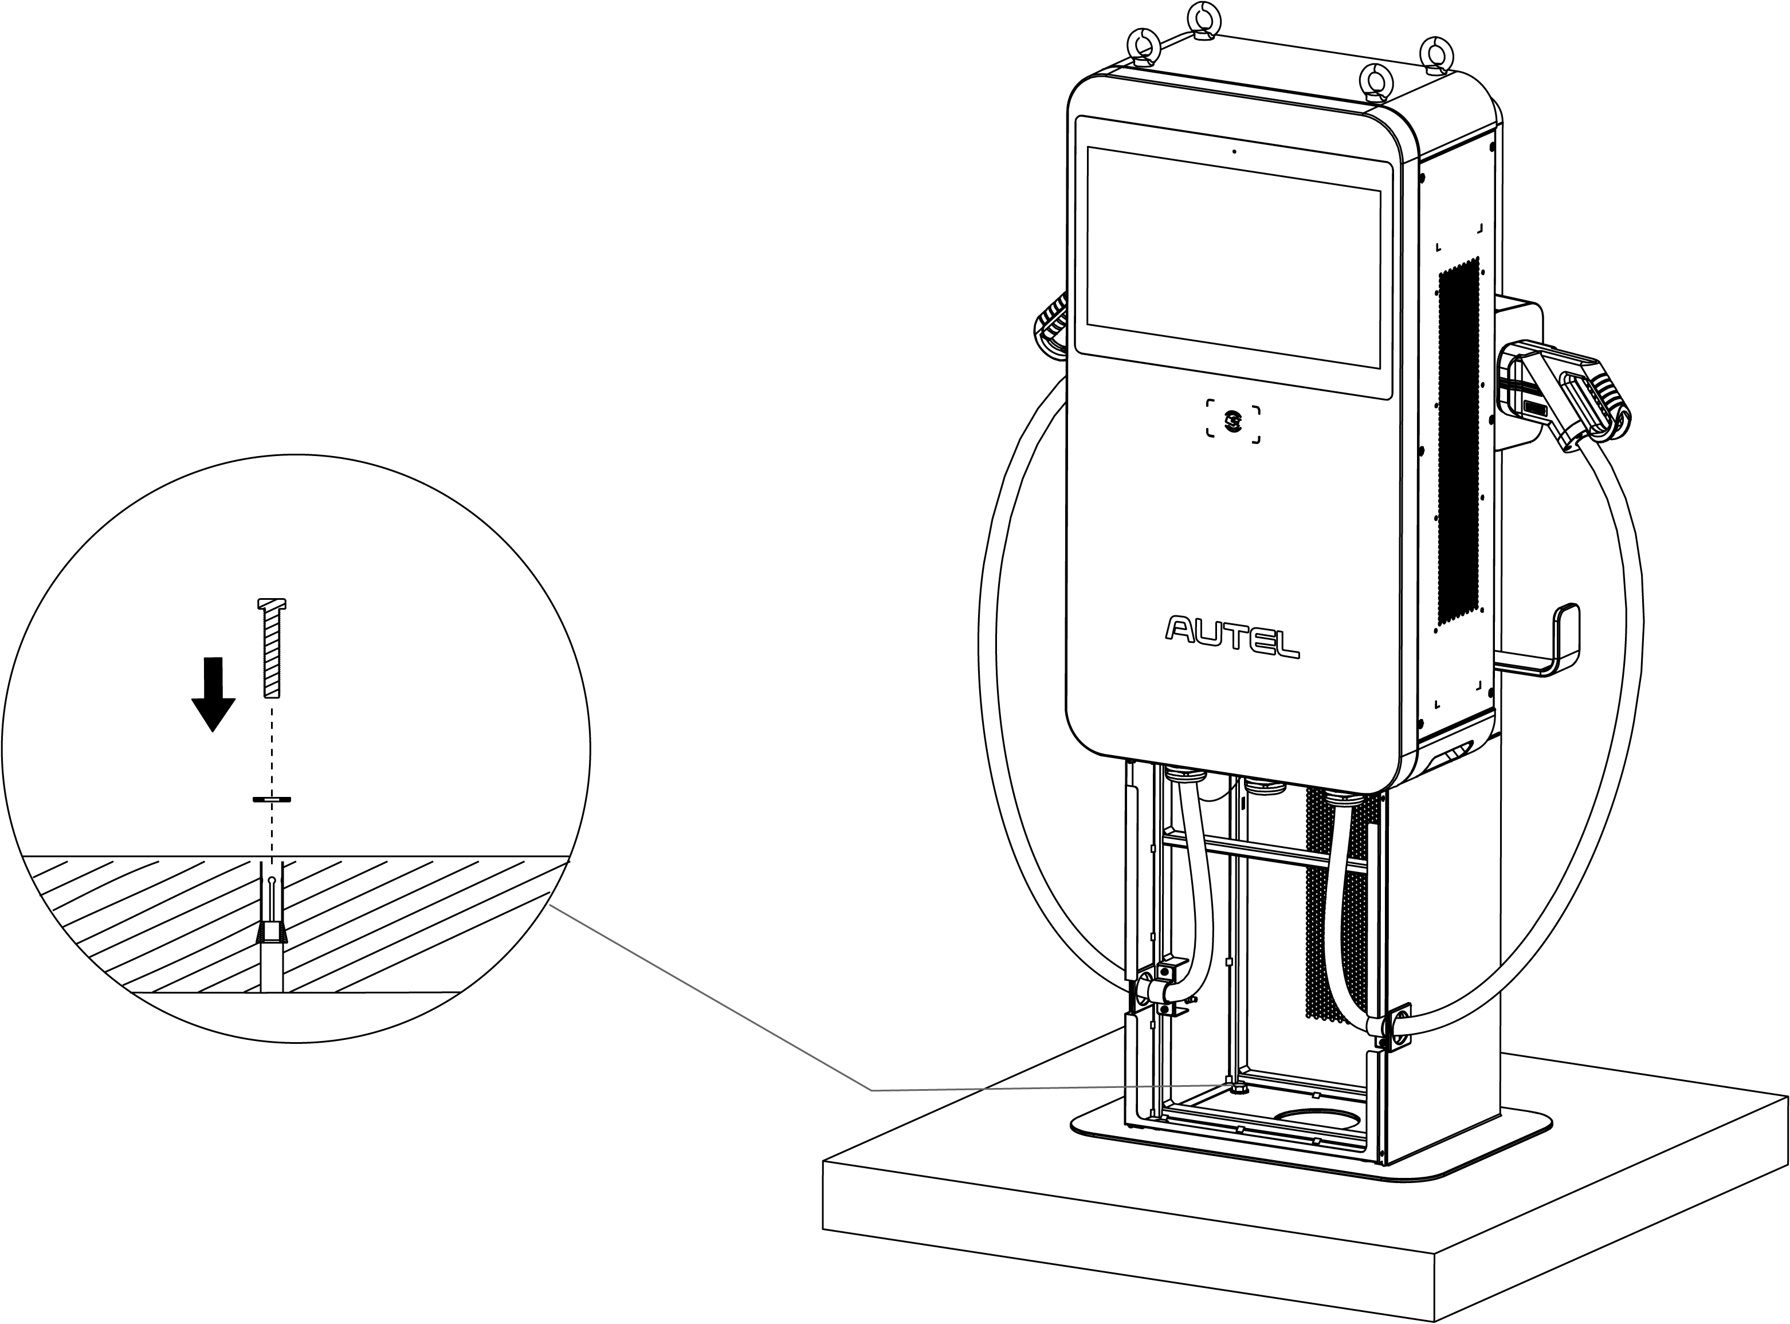

After the above installation steps are finished, you are ready to start power supply wiring. Please refer to ***Section 5.6*** to proceed.

**Completing the Installation**

1. Close the front door by reinstalling the two M8 hex screws using the hex key and tightening the screws.
2. Reinstall the side cover (**A**) by inserting and tightening the six M5 x 20 screws to 2 Nm using the T25 Torx screwdriver.



1. Reinstall the pedestal’s front cover by screwing the four M5 x 12 screws and tightening them to 2 Nm.



## Installing MaxiCharger and Trolley

**Checking the Package**

Ensure the following items can be found in the package.

|  |  |  |  |
| --- | --- | --- | --- |
| **MaxiCharger** |  | **Lifting Eye Bolt (M12)**  (4 PCS) |  |
| **Torx Screwdriver (T25)** |  | **Hex Key (6 mm)** |  |
| **Screw (M5 x 20) (For spare use)**  (4 PCS) |  | **Screw (M12 x 30)**  (2 PCS) |  |
| **Trolley** |  | **\*Industrial Plug (with Cable)** |  |

**Getting Started**

1. Use the Phillips screwdriver to loosen the four M5 x 12 screws to remove the front cover of the trolley. Set them aside.

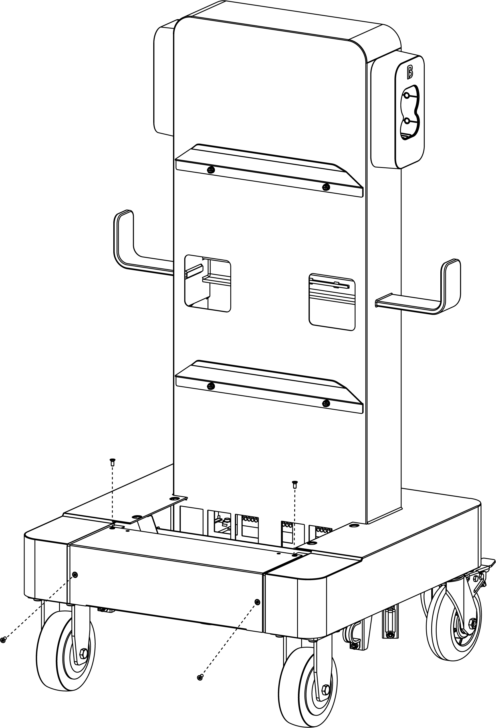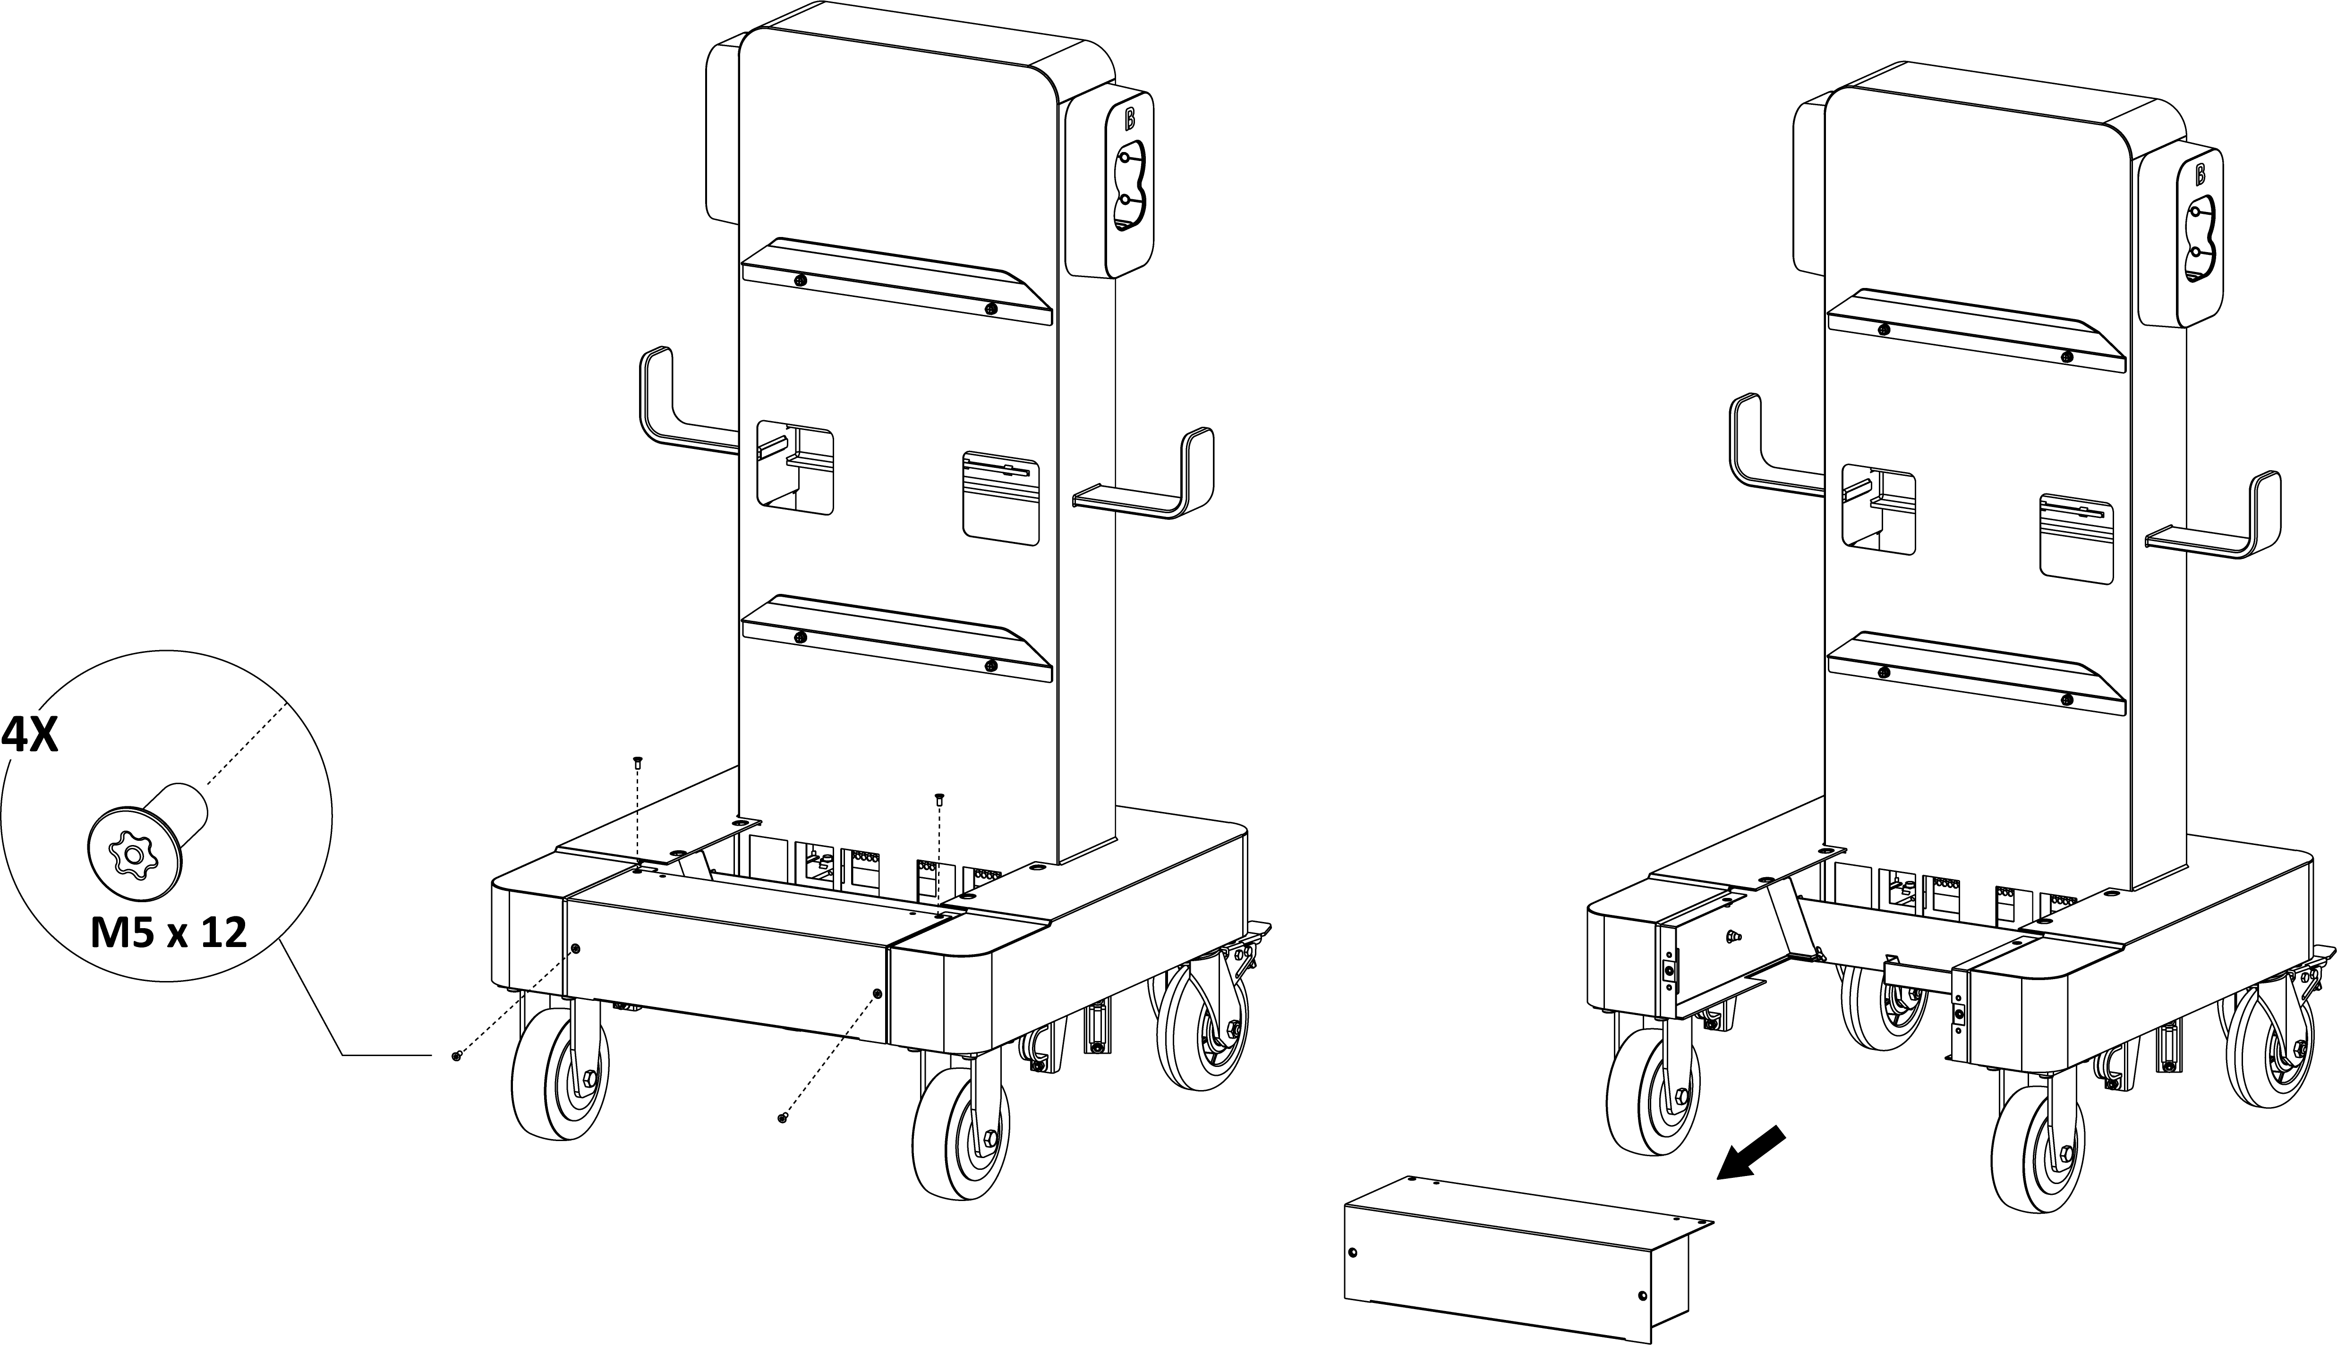

1. Lift the MaxiCharger onto the trolley. Position the groove (**B**) on the back of the MaxiCharger to fit the protrusion (**A**) of the trolley as shown below. Ensure the MaxiCharger is securely attached. Remove the four lifting eye bolts and reinstall the top screws.

**NOTE**

When lifting the MaxiCharger onto the trolley, press the foot brakes on the two rear wheels to prevent the trolley from movement.

1. Insert and fasten the two M12 x 30 screws using a 19 mm socket wrench to secure the MaxiCharger.

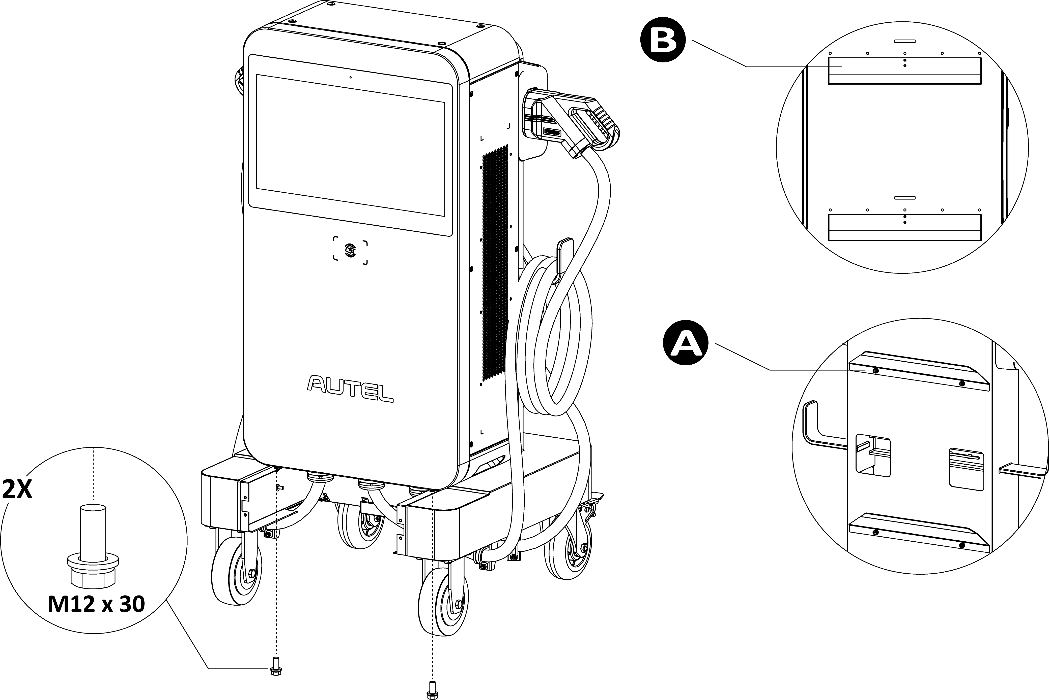

After the above installation steps are finished, you are ready to start power supply wiring. Please refer to ***Section 5.6*** to proceed.

**Completing the Installation**

1. Close the front door by reinstalling the two M8 hex screws using the hex key and tightening the screws.
2. Reinstall the side cover by inserting and tightening the six M5 x 20 screws to 2 Nm using the T25 Torx screwdriver.
3. Use the three strain reliefs to secure the cables. Tighten the M5 nuts using an 8 mm socket wrench.

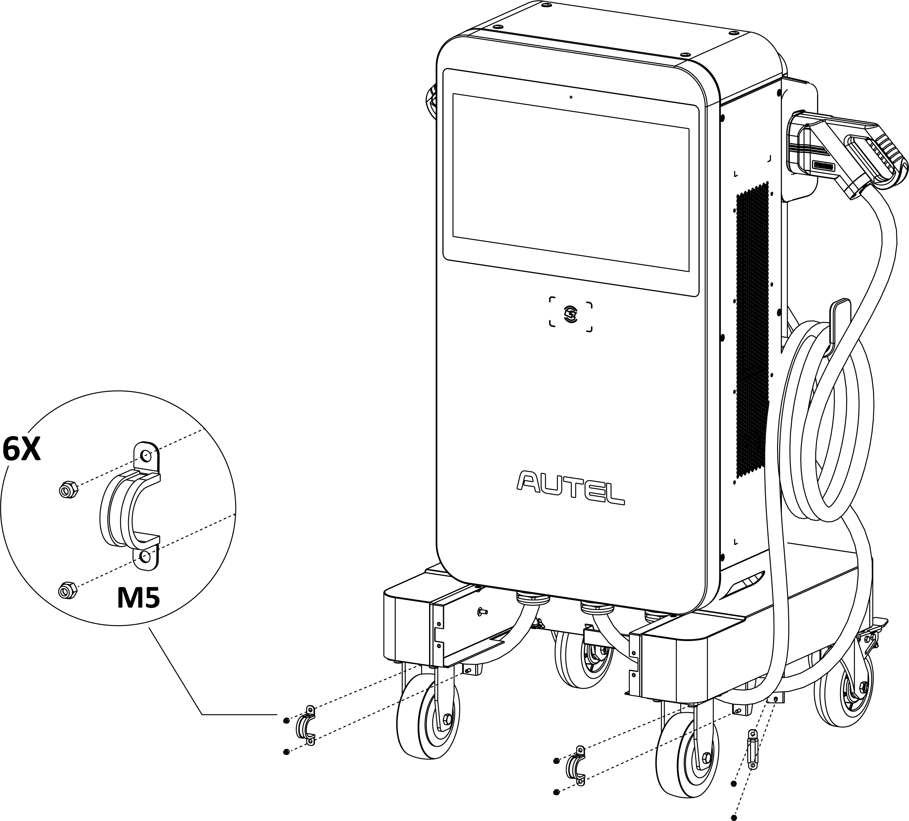

1. Reinstall the front cover of the trolley by inserting and tightening the four M5 x 12 screws.

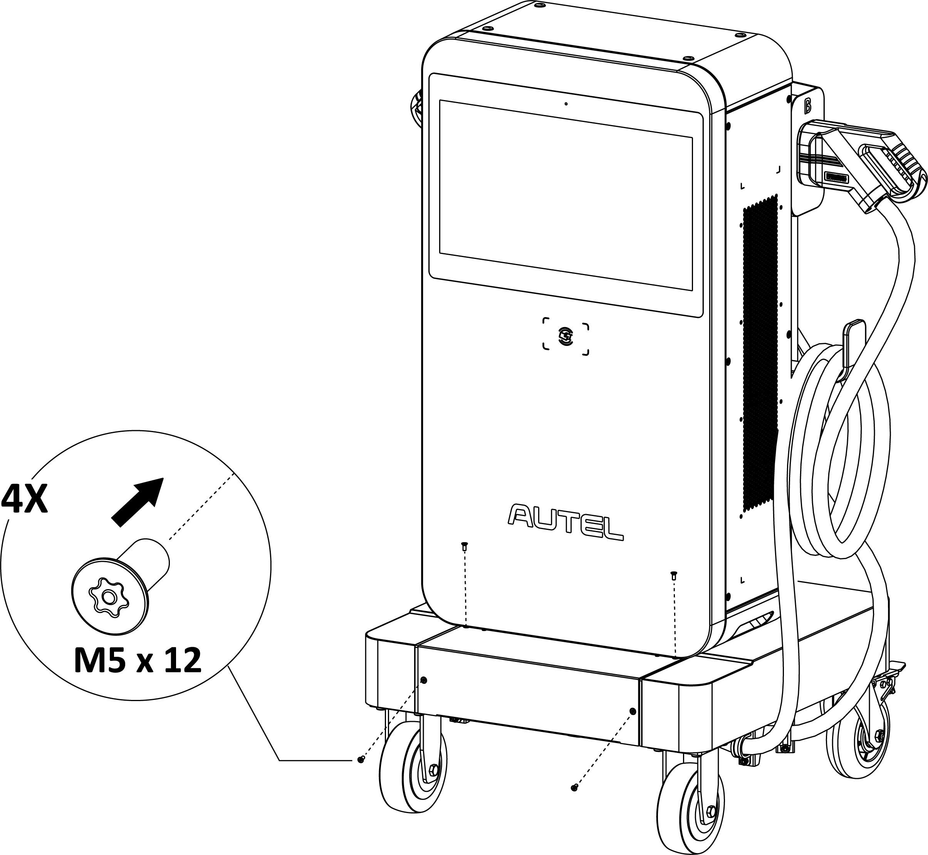

1. Drape the charging cables and industrial plug cable over the cable holders on the side and the rear respectively.

## Power Supply Wiring

**NOTE**

The MaxiCharger mounted on Trolley can skip this section.

**WARNING**

**Risk of Electric Shock**

* Only a qualified electrician should determine the electrical requirements and connect wires.
* Ensure the power is off before connecting the wires.

**IMPORTANT**

Before connecting the wires, ensure the following requirements are met:

* Use 75 °C copper wire only.
* The circuit breaker at the panel must be off.
* The MaxiCharger must be grounded to true earth.
* An insulated grounding conductor must be installed as part of the branch circuit that supplies the MaxiCharger.
* The grounding conductor should be grounded to earth at the service equipment or, when supplied by a separately derived system, at the supply transformer.
* All connections must comply with all local codes and ordinances.
* Use 25 mm2 wires.

### Opening the Door

1. Remove the six M5 x 20 screws on the right side of the MaxiCharger using the T25 Torx screwdriver to remove the side cover (**A**). Set them aside.

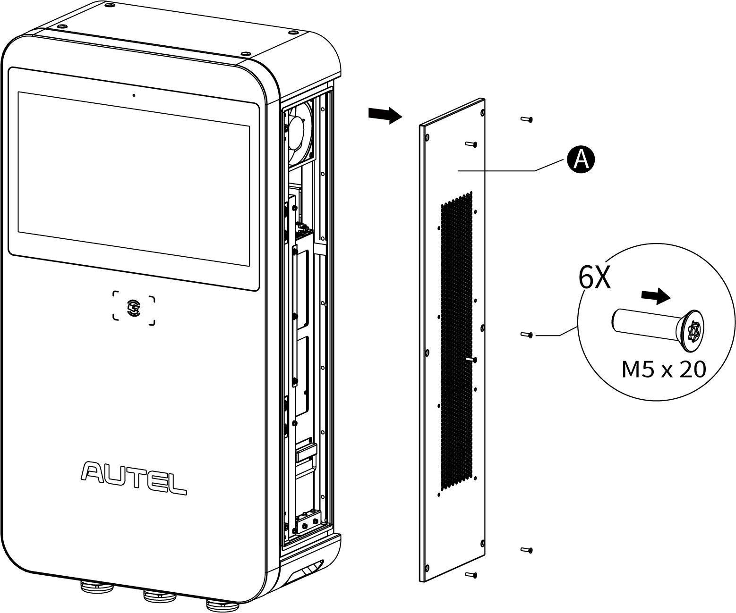

1. Loosen the two M8 hex screws (**A**) using the hex key and open the front door.

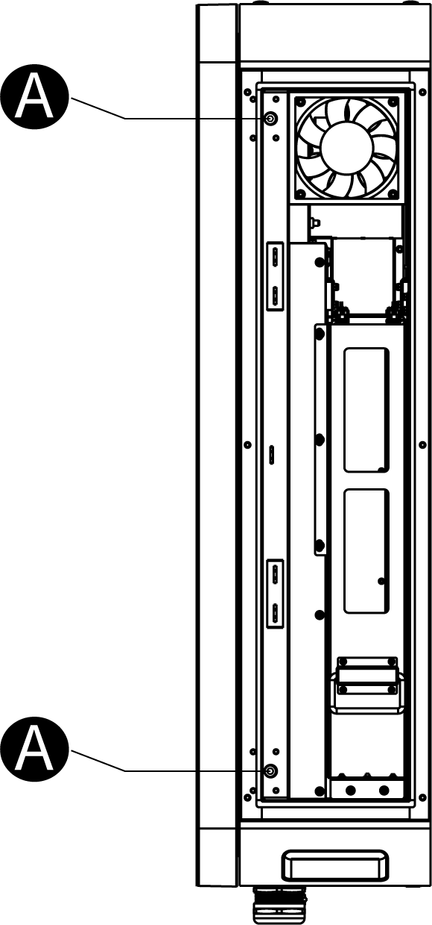

### Connecting the AC Input Cable

**NOTE**

Connect the industrial plug (with cable) provided to the terminal block inside the MaxiCharger for the MaxiCharger and Trolley.

1. Loosen the five M6 nuts a 10 mm socket wrench to remove the insulating barrier (**A**) and set them aside.

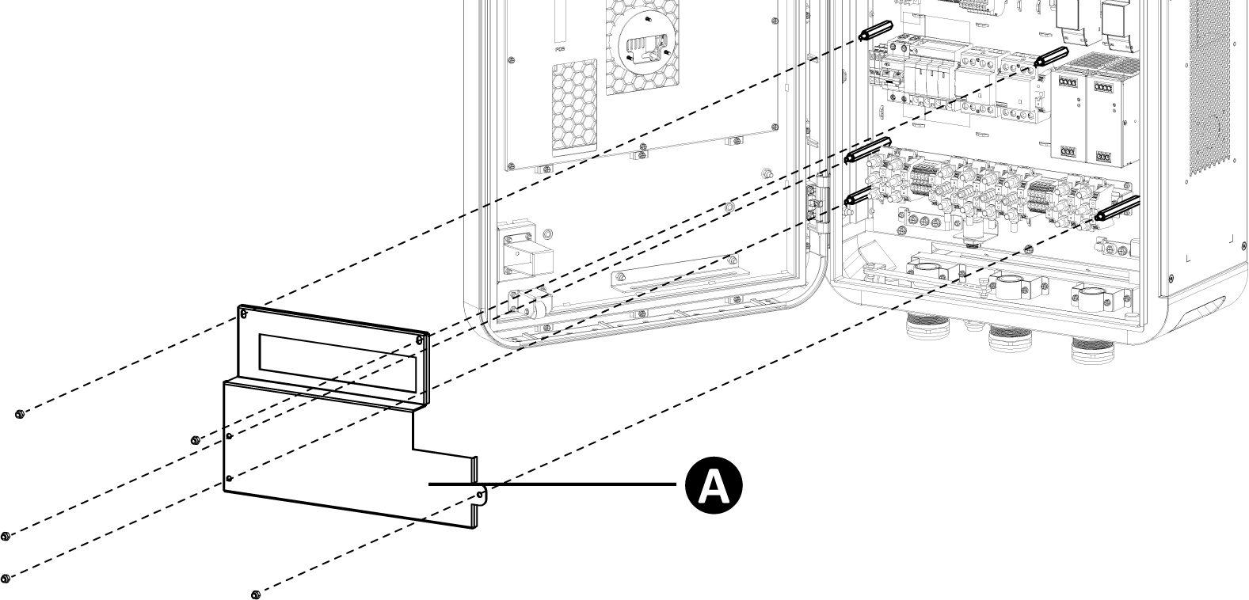

1. Pull the wires and guide them through the bottom AC inlet hole.
2. Use a wire stripper to remove an appropriate length of the insulation from the end of the wires. Ensure the stripped length is compatible with the cable lugs.
3. Use the crimping tool to attach the cable lugs to the end of the wires.

**NOTE**

The MaxiCharger and Trolley can skip the Step **3** and **4**.

1. Loosen the M6 fastener using a 10 mm socket wrench and connect the PE wire to the PE busbar (**A**). Reinsert the fastener and tighten it to 6 Nm.
2. Use a 13 mm wrench to loosen the four M8 fasteners and attach the wires to the connectors:

* L1 wire to the connector **B**
* L2 wire to the connector **C**
* L3 wire to the connector **D**
* N wire to the connector **E**

1. Reinsert the M8 fasteners and tighten them to the torque 6–12 Nm.

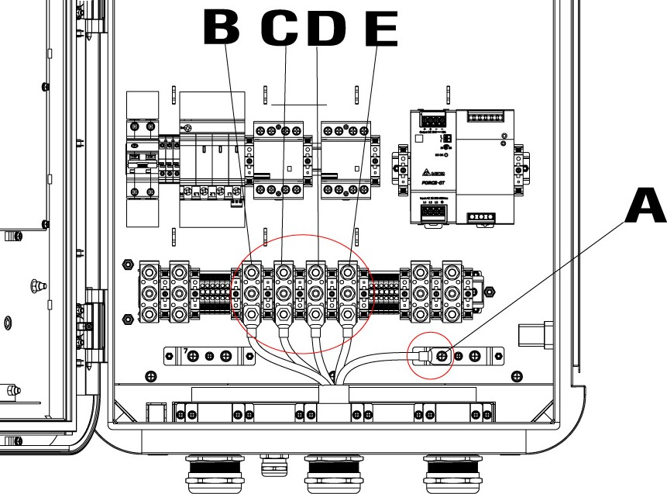

## Connecting to the Internet

The MaxiCharger can access the Internet via Ethernet Cable, Wi-Fi or cellular network. The installation process vary among different Internet connections. Select the optimal method to connect the Internet and follow the steps below accordingly.

### Via the Ethernet Cable

**NOTE**

For MaxiCharger and Trolley and MaxiCharger mounted on trolley, cellular data or Wi-Fi is preferred to access the Internet for movability.

1. Loosen the cable gland (**A**).
2. Put the Ethernet cable through the Ethernet cable port at the bottom of the MaxiCharger.
3. Plug the Ethernet cable into the RJ45 port.
4. Tighten the cable gland (**A**).

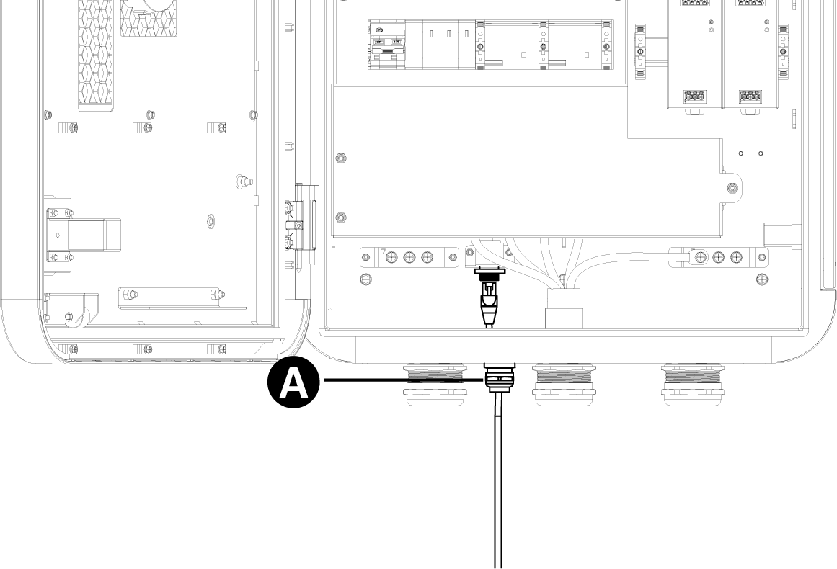

### Via the Cellular Network

1. Press the button (**A**) to release the SIM card tray.
2. Insert a SIM card into the tray. Ensure the card is placed correctly.
3. Push the SIM card tray into the slot.

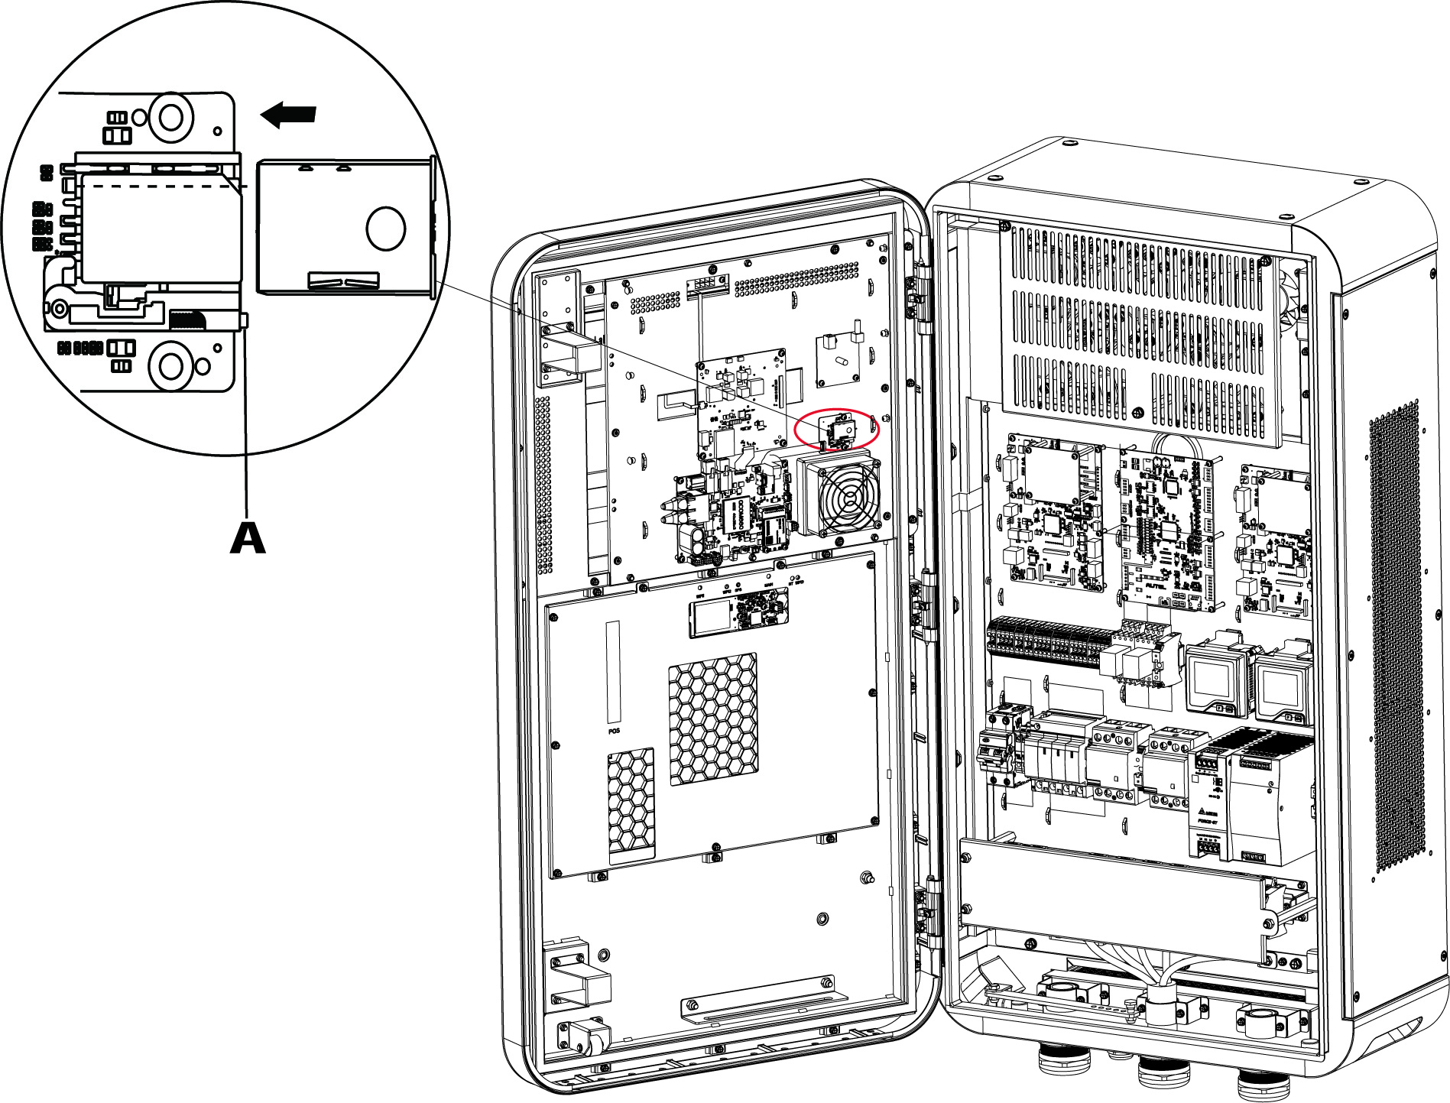

## Installing the Upstream Protective Device

|  |  |
| --- | --- |
| **Devices** | **Specifications** |
| Dedicated upstream protection device(s) | Options:   * RCD (Type A) + MCB * RCBO (Type A) |
| Upstream overcurrent protection breaker, such as RCBO or MCB  (The breaker serves as the main disconnect switch to the MaxiCharger.) | Breaker rating should not be less than 100 A.  Tripping characteristics: type C |
| Upstream residual-current device (RCD) | Type A, with a rated residual operation current of 30 mA |

## Connecting the Industrial Plug to the Socket

**IMPORTANT**

Before unplugging the industrial plug after the charging session is finished, cut off the power first.

This section applies for MaxiCharger and Trolley and MaxiCharger mounted on trolley. The industrial plug connection steps are as below:

1. Open the socket cover.
2. Insert the industrial plug into the socket and fully push the plug.
3. Rotate the bayonet ring (**A**) clockwise to secure the connection.

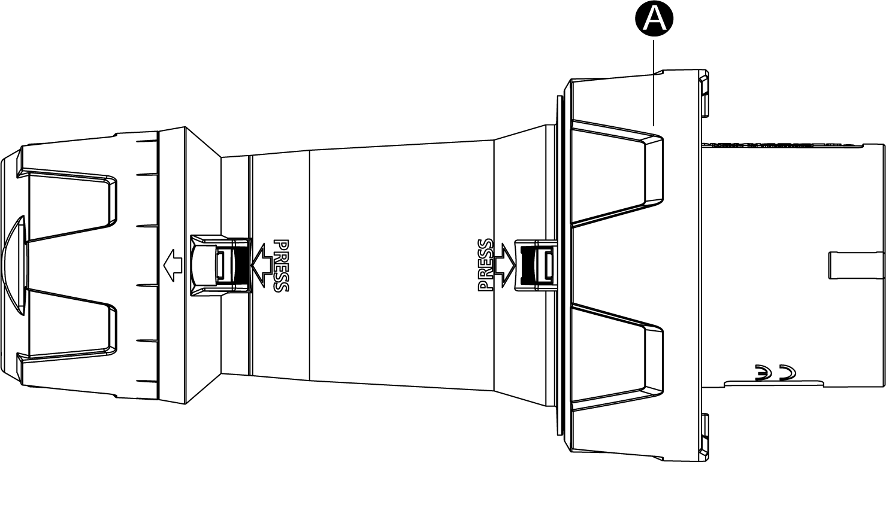

1. Turn on the local service panel switch to supply the power to the MaxiCharger.
2. Unplug the industrial plug after the charging session is completed.

## Preparing for Commissioning

**IMPORTANT**

Only a manufacturer qualified service engineer can commission the MaxiCharger.

* **To perform the commissioning**

1. Ensure the site complies the following requirements:

* The MaxiCharger is installed according to the instructions in this manual.
* AC input power is available.
* Internet access is available through a wired Ethernet connection, cellular service or Wi-Fi.
* An EV of each type of connector must be available for a compatible test during commissioning.
* The site operator or owner is available to receive instructions from the manufacturer certified service engineer when the MaxiCharger is installed.

1. Ensure the following information is collected:

* Name and address of the site
* Contact information of the on-site contact person
* Specification of the external fuse or breaker at the local service panel
* Date when the installation is done
* Photo of the MaxiCharger and the site surroundings
* Special remarks (if any)

1. Someone should be present for assistance to energize the power to the MaxiCharger on the local service panel.

**IMPORTANT**

The conduit opening must be sealed to protect the wiring from the environment.

## Powering on the MaxiCharger

**Before Power-on**

* Install the MaxiCharger according to the instructions in this manual.
* Prepare an emergency plan to instruct people what to do in case of an emergency.
* Only the manufacturer or a qualified technician authorized by the manufacturer can commission the MaxiCharger. Contact the manufacturer when the MaxiCharger is ready for commissioning.

**NOTE**

In the event of ambient temperature lower than -20 °C, it will take 3~5 minutes to preheat the screen when powering on the MaxiCharger. In extreme cases, the display module will be reset to ensure the stability of the MaxiCharger.

* To power on the MaxiCharger

1. Make sure that the upstream breaker stays in the **OFF** position and locked during the procedure.
2. Tighten the screws and bolts of key parts and make sure the cabinet is clean inside. Prevent the electronic components from being damaged by dust or particles.
3. Use the multimeter to check the circuit connections among L1, L2, L3, N, and PE. If short circuit occurs, contact Autel technical support; otherwise, reinstall the insulating barrier.
4. Contact Customer Technical Support to turn on the upstream breaker and check the indicators on CCU, ECU, and TCU and the screen display.

* If any indicator of CCU, ECU or TCU is off or the screen display is abnormal, please contact Autel technical support;
* If all indicators and the screen display normal, go to next step.

1. Reinstall the insulating barrier after commissioning is completed.

# Operation

## Charging Procedure

General charging procedures:

* **To charge an EV**

1. Park an EV with the charging port within reach of the connector.
2. Plug in the EV.
3. Start the charging session.
4. ****Stop the charging session.

**WARNING**

* Do not cover the vent during charging.
* Do not clean or operate in the EV during charging.

### Standby Mode

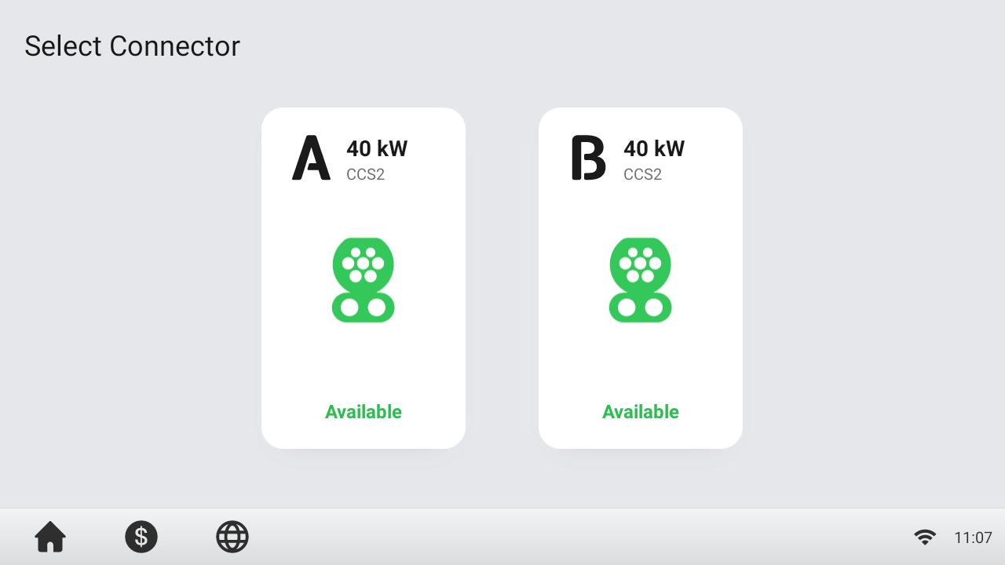

After a connector is successfully connected to your EV, the MaxiCharger can automatically recognize the connector, then the corresponding connector’s Authorization Screen will appear.

If no operation is performed for a long time on the Authorization Screen, the Standby Screen will appear. Manually select the appropriate connector on the touchscreen.

### Authorization

**IMPORTANT**

* Observe the screen for any abnormalities, such as an error messages, before starting a charging session. Check the surroundings and the MaxiCharger for any abnormalities and damage as well.
* If the screen displays an error message, **DO NOT** use the MaxiCharger. Contact Autel Technical Support.

When the Authorization Screen appears, you can use any of the following methods to start a charging session.

* Scan the QR code on the screen
* RFID card
* Plug & Charge
* Credit card (optional)

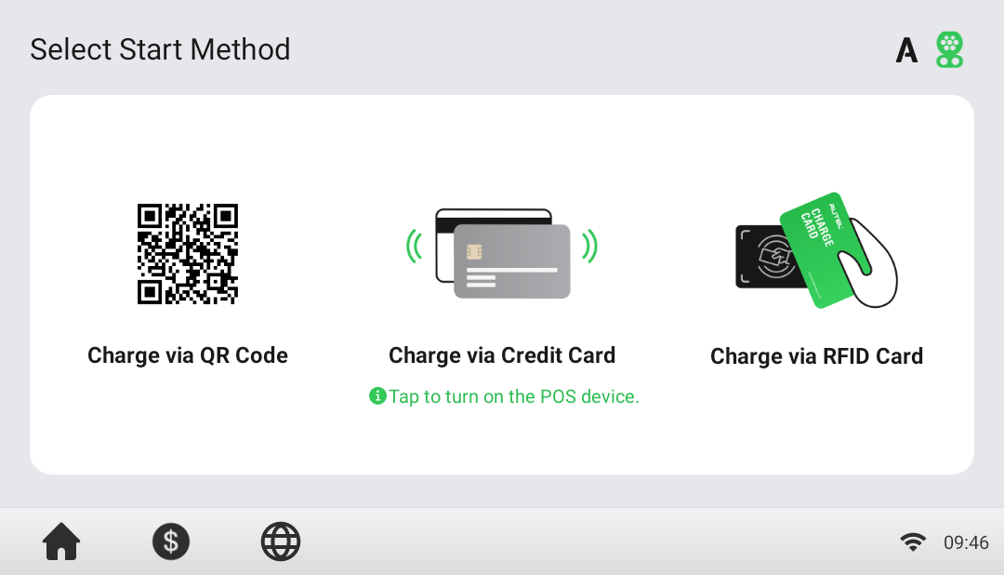

### Start Charging

After authorization, the MaxiCharger will set up communication with your EV and necessary safety tests will be performed. Following the safety tests, the charging session will start automatically.

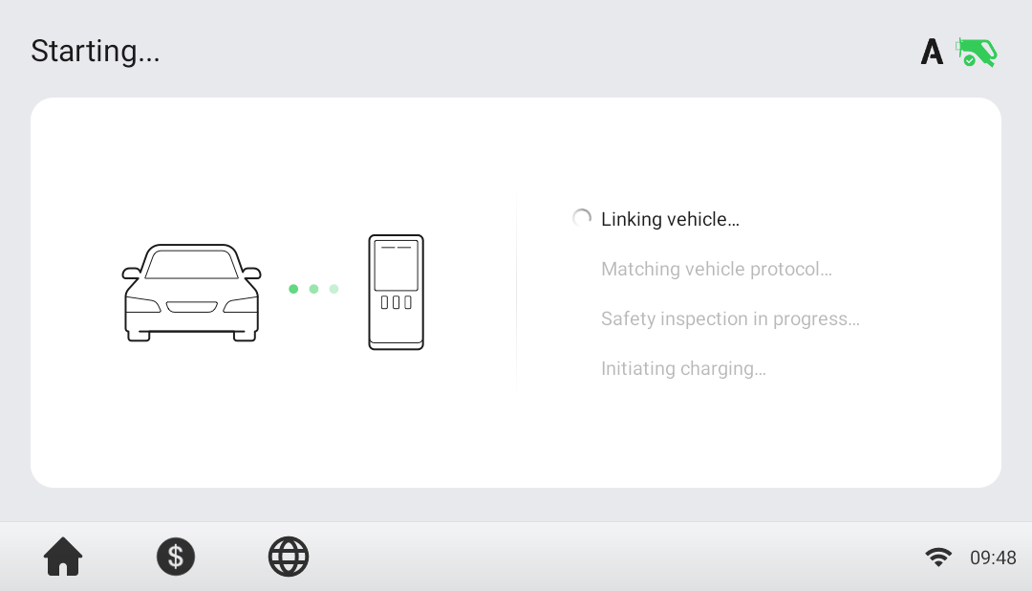

### Charging

You will be informed of the progress during charging. Information about the charging duration, energy, cost, and power will appear on the Charging Screen.

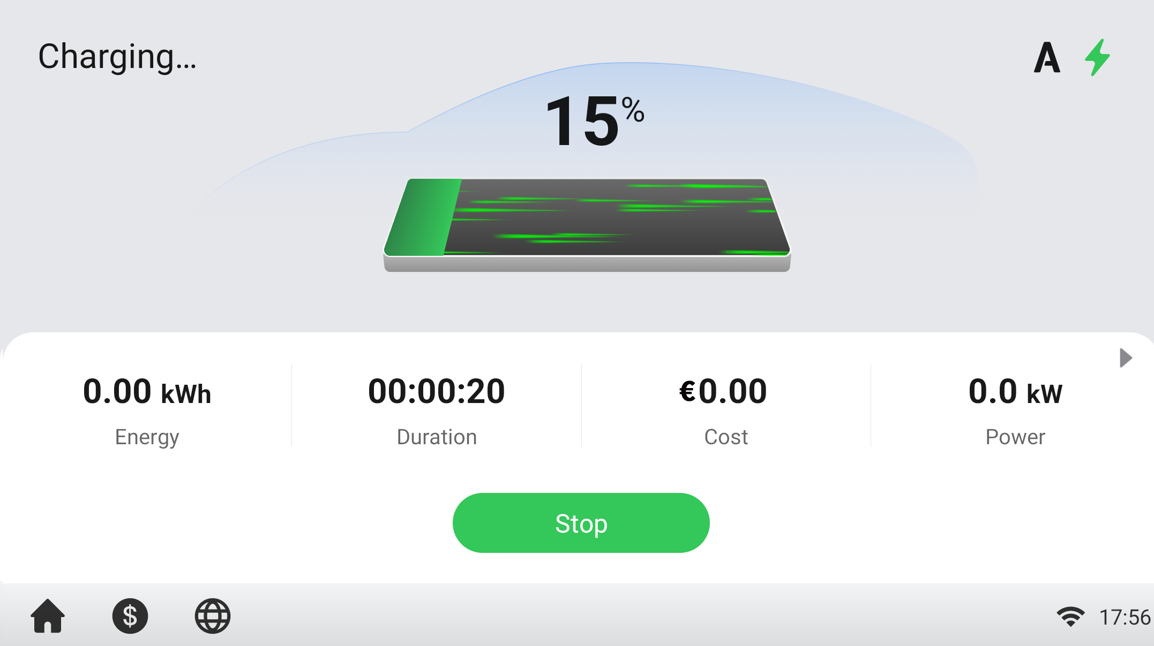

### Stop Charging

* To stop charging

1. Tap the **Stop** button on the screen.

**NOTE**

When the battery is full, the charging session stops automatically.

1. Normally, you have to authorize again to finish charging, using the same authentication method as was used to start:

* QR code: Scan the QR code with the Autel Charge app and tap the **Stop** button on the Charging Screen of the Autel Charge app.
* RFID card: Put the RFID card on the card reader again to finish charging.
* Credit card: Finish charging directly.

1. When charging is finished, your transaction details will appear.

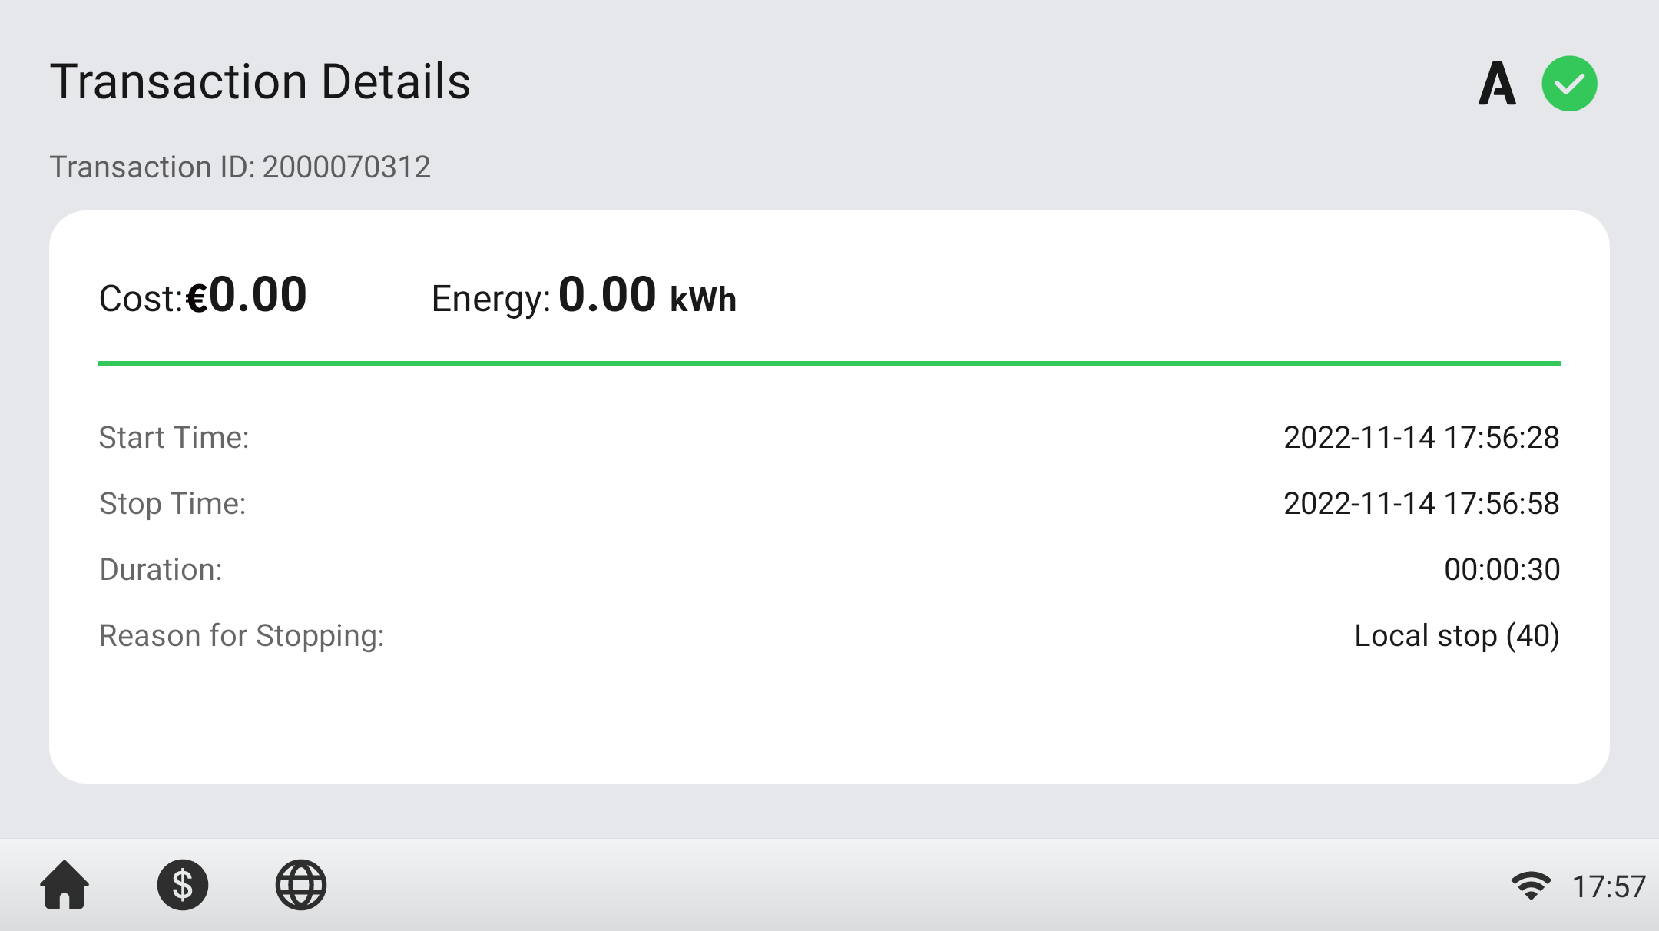

1. Disconnect the EV charging cable from the EV.

### Finish Charging

Return the connector to the holster on the MaxiCharger.

## Charging Errors

This section depicts several common problems that may arise during your charging session, along with possible causes/solutions to help you resolve those problems. If the problem persists, contact your local dealer or Autel Technical Support.

### Connector Connection Error

If the connector is not properly connected to your EV, then the Connector Not Connected screen will appear. Insert the connector into your EV’s charge port and check the connection.

### Authorization Failure

If an error occurs when you start the authorization process but without starting charging, the Authorization Failure screen will appear. The cause and possible solution(s) will display on the screen. Follow the on-screen instructions to resolve the problem, or contact your local dealer or Autel technical support.

### Charging Start Failure

If an error occurs when you start charging, the Charge Start Failure screen will appear. The cause and possible solution(s) will display on the screen. Follow the on-screen instructions to resolve the problem.

### Charging Failure

If an error occurs during charging, the Charging Failure screen will appear. The cause and possible solution(s) will display on the screen. Follow the on-screen instructions to resolve the problem, or contact your local dealer or Autel Technical Support.

## Emergency Stop

When detecting emergency stop signal sent from the EV during charging, the MaxiCharger will immediately stop DC output. As a result, the voltage and current will be dramatically reduced to 60 V and 50 A in 30ms. The DC output contactor will also be disconnected.

## Powering down the MaxiCharger

* To power down the MaxiCharger

1. Set the upstream breaker which provides the power to the MaxiCharger to **OFF** and lock it. Make sure that this breaker stays in the **OFF** position during the procedure.
2. Open the front door.
3. Measure the AC voltage by referring to *Measuring the AC Voltage*. Make sure that all the measured voltages are 0 volts.
4. Measure the DC voltage by referring to Measuring the DC Voltage. Make sure that all the measured voltages are 0 volts.
5. Close the front door.

### Measuring the AC Voltage

Use a voltage tester to measure the AC voltage between the terminals on the surge protection device switch:

* L1 to L2
* L1 to L3
* L2 to L3
* N to L1/L2/L3

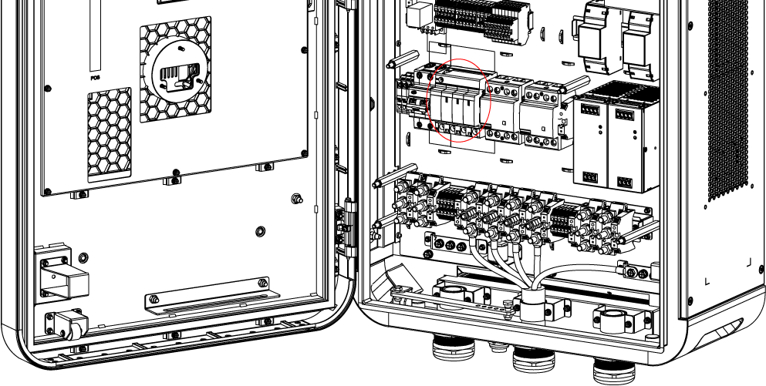

**NOTE**

The surge protection device switch shows the indica tions N, L1, L2, and L3.

### Measuring the DC Voltage

Use a voltage tester to measure the DC voltage between the output terminals, making sure that all the measured voltages are 0 volts.

* Power module group output 1 — (**A**) to power module group output 1+ (**B**)
* Power module group output 2 — (**C**) to power module group output 2+ (**D**)
* EV charging cable 1 output — (**E**) to EV charging cable 1 output + (**F**)
* EV charging cable 2 output — (**G**) to EV charging cable 2 output + (**H**)

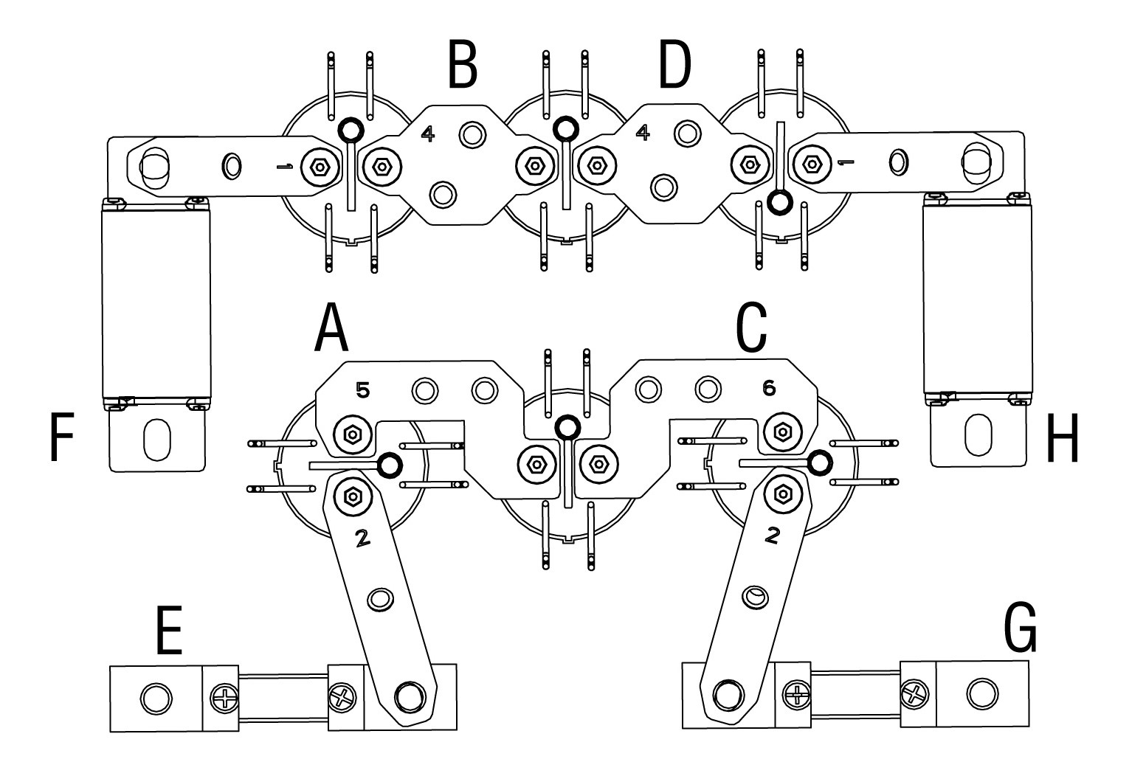

## Local Service Portal Operations

### Setting the OCPP Parameters

**NOTE**

The OCPP parameter setting should be performed by an installation engineer.

* To set the OCPP parameters

1. Tap the upper-left corner of the screen.
2. Tap **Device Maintenance**. Enter the default password (contact Autel customer service to obtain the password).
3. Tap **Set Parameters**. Wait for the system to load the data. This can take a few seconds.
4. Set the following parameters:

* **Running environment**: current running environment
* **OCPP IP**: IP address of the OCPP
* **OCPP URL**: URL of the OCPP
* **OCPP PORT**: port number of the OCPP
* **MGR IP**: IP address of the management platform
* **MGR URL**: URL of the management platform
* **MGR PORT**: port number of the operational management platform

**NOTE**

Make sure that the URL or ID you type is correct and without spaces.

1. Tap **Save** to save your changes.

# Maintenance

## Routine Maintenance

Routine maintenance can keep the MaxiCharger in safe and stable state.

* Clean the MaxiCharger every quarter: tighten the screws and bolts of key parts, and check whether the wire connection of the MaxiCharger’s connector is burned out. If any abnormality is found, replace the parts promptly.
* Clean the filter at least twice a year.
* Test the residual current device once a year.

**WARNING**

* Disconnect the power supply to the MaxiCharger during the entire maintenance procedure.
* Make sure that unauthorized personnel are kept at a safe distance during maintenance.
* Wear proper personal protective equipment, such as protective clothing, safety gloves, safety shoes, and safety glasses.
* If you remove the safety devices for maintenance, reinstall them after completing the work.

### Residual Current Device Maintenance

**WARNING**

Be careful when you work with electricity.

The internal residual current breaker with overload (RCBO) should be tested annually for correct functioning. Before testing, disconnect the MaxiCharger with the EV and stop any charging processes.

* **To test the RCBO**

1. Open the front door of the MaxiCharger. When the cabinet door is opened, the MaxiCharger should not be directly exposed to wind and rain.
2. The MaxiCharger must be in Standby mode. Tapping the touchscreen will wake up the MaxiCharger.
3. Locate the RCBO, and press the **Test** button to start the test.

* Pass: The RCBO will trip and restore the **Test** button to its original position.
* Fail: The RCBO does not trip. Please contact Autel technical support. Do not use the MaxiCharger until the repair is completed.

1. Close the front door after the test is finished.
2. Mark the time when the test is needed to be repeated annually.

### Cleaning the MaxiCharger

The MaxiCharger is powder-coated. The coating must be kept in good condition. When the MaxiCharger is in a corrosion sensitive environment, superficial rust may appear on welding points. Visible rust has no risk to the integrity of the MaxiCharger.

* To remove rust

1. Stop any charging processes and power off the MaxiCharger.
2. Remove rough dirt by spraying with low-pressure tap water.
3. Apply a neutral or weak alkaline cleaning solution and let it soak.
4. Remove dirt by hand with a damp and non-woven nylon cleaning pad.
5. Rinse thoroughly with tap water.
6. Apply wax or a rust-preventive primer for extra protection if needed.

**WARNING**

* Before cleaning, stop any charging processes and do not connect the power to the MaxiCharger. Failure to do so may cause damage and/or personal injury or death.
* Do not apply high-pressure water jets and avoid water leaking into the MaxiCharger. Make sure that the inside of the MaxiCharger is dry during cleaning.
* Do not use caustic solvents, sprays, solvents or abrasives. Use cleaning agents with a pH between 6 and 8 for strong stains only.

### Cleaning and Replacing the Filter

**WARNING**

* Before cleaning, stop any charging processes and do not connect the power to the MaxiCharger. Failure to do so may cause damage and/or personal injury or death.
* Do not apply high-pressure water jets and avoid water leaking into the MaxiCharger. Make sure that the inside of the MaxiCharger is dry during cleaning.
* Do not use caustic solvents, sprays, solvents or abrasives.

The MaxiCharger is equipped with a filter with a large mesh area to prevent the electronic components from being damaged by dust. Clean the filter every 3 months (not to exceed 6 months). Replace the filter annually.

* To clean or replace the filter

1. Before cleaning and replacing, be sure to stop all charging processes, disconnect the external power supply, and perform the power-off protection.
2. Open the two toggle latches (**A**) at the bottom of the MaxiCharger to flip the bezel (**B**) downward.
3. Remove the filter (**C**).
4. Clean debris or dust of the filter and reinstall a cleaned filter. Alternatively install a new air filter.
5. Flip the bezel (**B**) upwards and close the two toggle latches (**A**).



## Inspection and Maintenance

When the MaxiCharger operates normally, only routine maintenance is needed.

When the MaxiCharger operates abnormally, refer to ***Troubleshooting*** to resolve the problem or contact your local dealer or Autel Technical Support promptly.

When parts need to be replaced, completely cut off the power supply upstream and inside the equipment before operating.

Regularly conduct a visual inspection of the following points:

* Cable and connector: Check for cracks or ruptures on the connector or cable.
* Display: Check for damage and cracks. Check whether the touchscreen works.
* MaxiCharger coating: Check for damage, cracks or ruptures.
* MaxiCharger: Check for rust or damage.

The following special inspections are needed for safe use:

* Check if the MaxiCharger was struck by lightning.
* Check if the MaxiCharger was damaged due to an accident or fire.
* Check the MaxiCharger installation site has been flooded.

**WARNING**

Stop any charging processes and do not connect the power to the MaxiCharger until all the inspections are complete.

## Remote Maintenance

The MaxiCharger has the function of connecting to cloud platform to monitor parameters in real time. This provides remote upgrades, remote diagnosis, and remote service functions, and can timely identify and locate problems in the operation process.

* System self-check for abnormality daily.
* If any operation abnormality is found, contact your local dealer or Autel technical support promptly.
* Autel service engineers can check logs, update configurations and programs, and provide remote maintenance services, such as remote management, diagnosis, configuration, and upgrades.

## Maintenance Schedule

|  |  |  |
| --- | --- | --- |
| **Item** | **Frequency** | **Actions** |
| Connector | Every 3 months | Check for cracks or ruptures on the connector. |
| Input Cable | Every 3 months | Check for cracks or ruptures on the cable. |
| Filter | Annually | Replace the filter. |
| MaxiCharger | Every 3 months | Clean and check for damage. |

# Troubleshooting and Service

## Troubleshooting

The table below describes the most common faults when operating the MaxiCharger. Contact Autel technical support if the fault encountered is not in this table.

| Error | Error Code | Possible Cause | Solution |
| --- | --- | --- | --- |
| CP voltage abnormal | 0x2037 | It may be caused by signal interference, poor contact or software errors. | Perform remote restart or reset. If the fault persists, contact Autel technical support. |
| Communication error with the entire charging module group | 0x3011 | There is a problem with the module’s address setting. | Power off the MaxiCharger and restart it. |
| Overvoltage | 0x202D | The DC output voltage is above the upper limit of the vehicle or the rated voltage of the MaxiCharger during charging. | Stop the charge session and contact Autel technical support. |
| Communication error with the power control module | 0x200E | The CCU does not receive messages from the ECU and the communication is timed out. | Perform remote restart or reset. If the fault persists, contact Autel technical support. |
| BMS communication error | 0x2007 | It may be caused by charging incompatibility. | Perform remote restart or reset. If the fault persists, contact Autel technical support. |
| Cooling fan abnormality | 0x304A | Fan aged or damaged. | Power off the MaxiCharger and contact Autel technical support for repair or replacement of the fan. |
| Charging port electronic locking fault | 0x2002 | It might be caused by a vehicle-related fault. | Contact the vehicle manufacturer and Autel technical support. |
| CCU auxiliary power supply shutdown | 0x202C | Sever power fault due to aged key components or lines. | Power off the MaxiCharger. Then locate the faulty component or line and contact Autel technical support for its repair or replacement. |
| Meter communication error | 0x0001 | Aged meter or line. | Stop the charge session and contact Autel technical support. |
| Insulation monitoring fault | 0x2003 | If it appears from time to time, it might be due to the vehicle or software error; if it appears frequently, there may be an aged key component. | Perform remote restart or reset. If the fault persists, contact Autel technical support. |
| AC contactor stuck | 0x3008 | AC contactor fault or line aging | Power off the MaxiCharger and contact Autel technical support. |
| FPGA fault | 0x3010 | Controller fault | Stop the charge session, power off the MaxiCharger, and contact Autel technical support. |
| CCU current sampling and module output current accumulation fault | 0x3014 | Charging module output or sampling fault | Perform remote restart or reset. If the fault persists, contact Autel technical support. |
| Power distribution contactor sticking (charging possible) | 0x3047 | Contactor or sensor fault or line aging | Power off the MaxiCharger immediately and contact Autel technical support. |
| Communication error on one charging module | 0x3051 | Abnormal charging module | Contact Autel technical support to identify the fault, and then clear the fault or replace the module. |
| Fan fault with one charging module | 0x305A | Abnormal charging module | Contact Autel technical support to identify the fault, and then clear the fault or replace the module. |
| Inconsistent CCU voltage sampling and the module output voltage | 0x305C | Abnormal charging module | Contact Autel technical support to identify the fault, and then clear the fault or replace the module. |
| Insulation detection alert | 0x2040 | If it is a one-time problem, there is may be a falling object, and no operation is required; if it has occurred for several times, the connector cable may be damaged or there are foreign objects in the busbar. | Power off the MaxiCharger immediately and contact Autel technical support. |
| Charger offline | 0x9001 | Communication error between gateway and the Autel Charge Cloud | Check the network connection and OCPP configurations. |

## Service

If you cannot find solutions to your problems with the aid from the table above, please contact Autel Technical Support.

AUTEL Europe

* **Phone**: +49(0)89 540299608 (Monday–Friday, 9:00 AM–6:00 PM Berlin Time)
* **Email**: evsales.eu@autel.com; evsupport.eu@autel.com
* **Address**: Landsberger Str. 408, 4. OG, 81241 Munich, Germany



**www.autelenergy.com**